IlBIfll

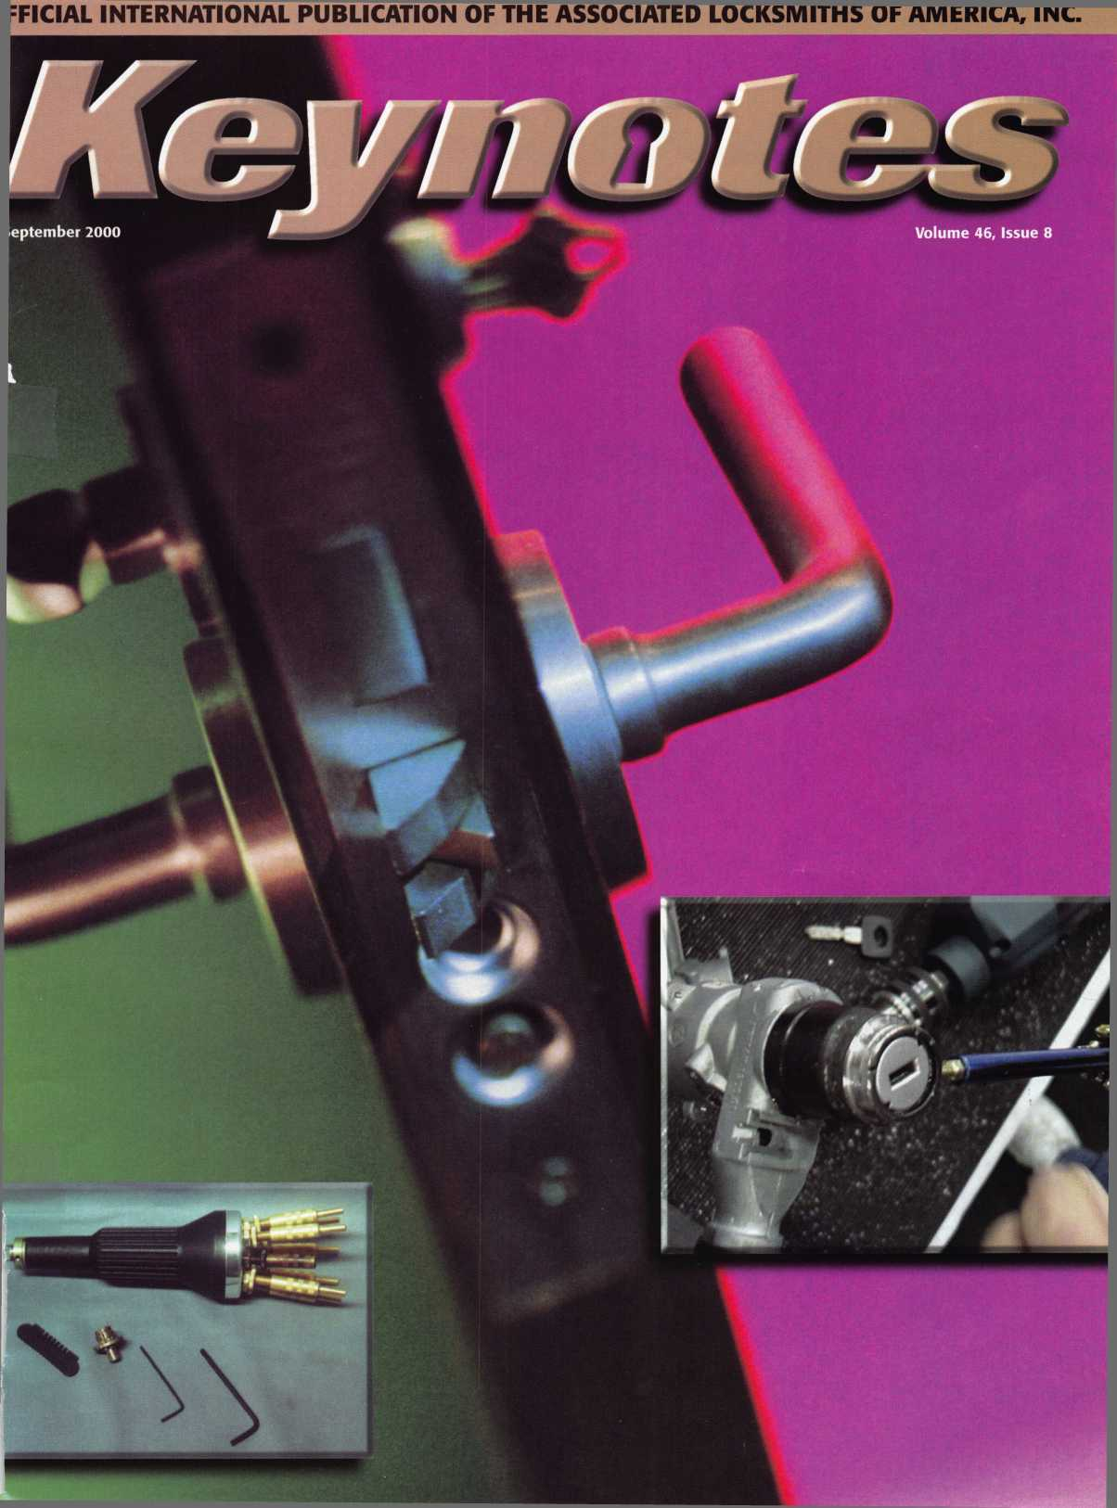

**Jump ahead of the competition  
at warp speed and see your profits soar.**

Hickok’s New Generation STAR transports you with its advanced programming  
for keys to Ford-Lincoln-Mercury vehicles with passive antitheft systems.

Program vehicle keys through MY2000 with Hickok’s NGS Model 800-8LA—S1995

**HICKOK**

**INCORPORATED**

**phone 800/342-5080  
[www.hickok-inc.com](http://www.hickok-inc.com)**

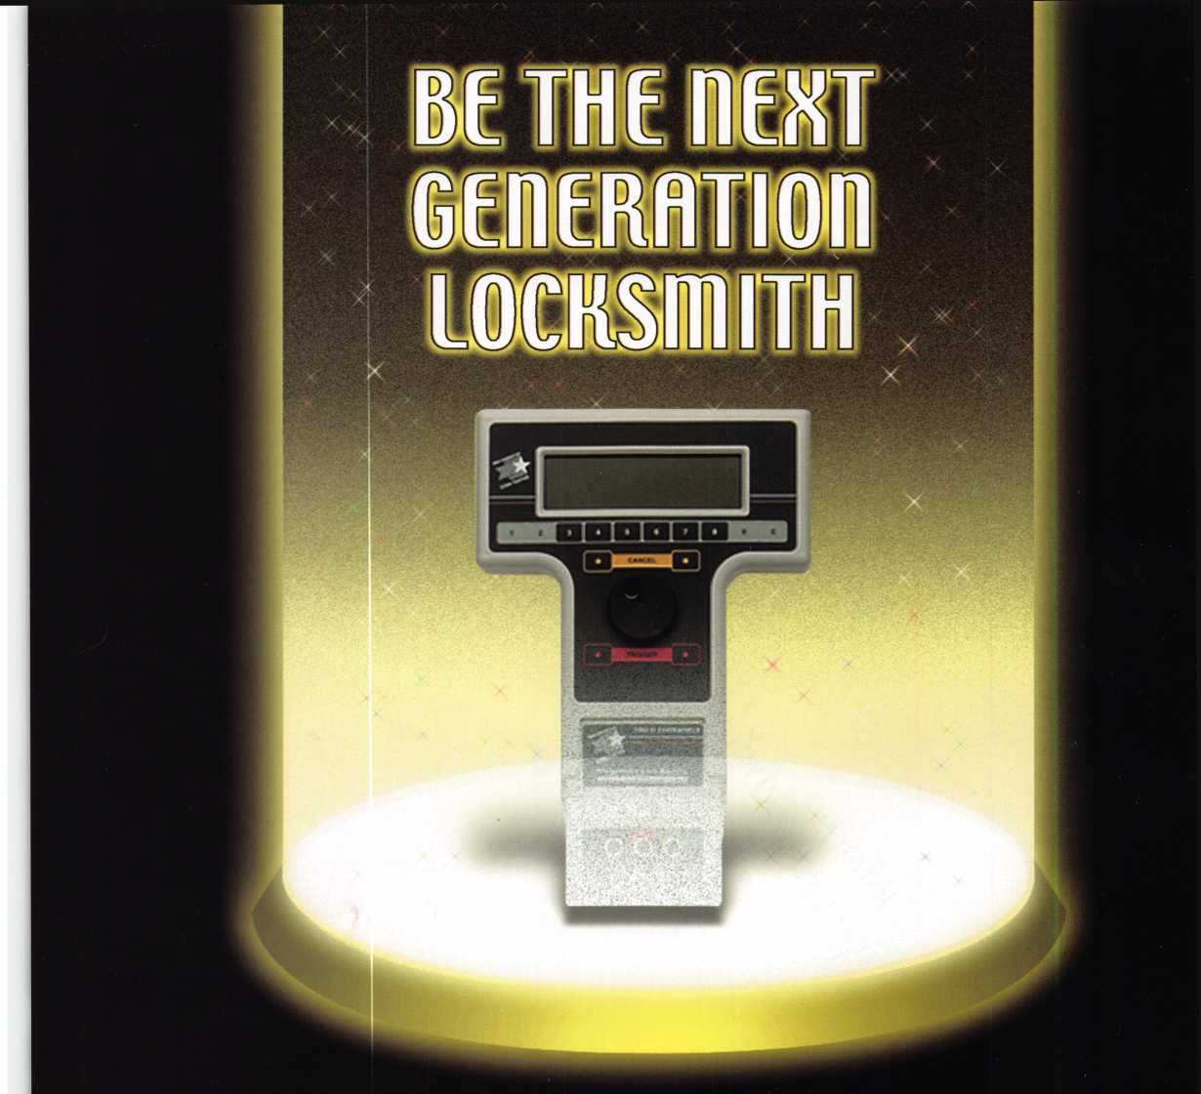

The consensus is universal—

ALOA 2000 in Las Vegas was a "big bang"!

But events like this year's don't just happen—  
not without the billions and billions...well, at least many thousands of  
members, volunteers and exhibitors who attended.

ALOA would like to take this opportunity to express special thanks to everyone  
who helped make ALOA 2000 a brilliant success!

*

A special acknowledgement goes to the stars of ALOA 2000—our sponsors.  
Their support is vital to the launching of this great event, as well as  
the expansion of our industry's universe.

A & B Safe Corporation  
Abloy Lock Mfg.

Adams Rite Mfg. Company  
Adesco Mfg. Company  
American Lock Company  
American Security Products  
ALOA Scholarship Foundation  
Auto Security Products  
BWD Automotive Alabama  
Compx Security Products

**SCHLAGE.**

• MASTER KEY SPONS&RS

Yale Security, Inc. IDN Inc.

CHANGE KEY SPONSORS

DETEX Corporation  
Direct Security Supply  
Don-Jo Manufacturing, Inc.

* Escalera, Inc.

Gardall Safe Corporation  
Hayman Safe Company  
High Tech Tools  
llco Unican Corp.

Kustom Key, Inc.  
Kwikset

Lockmasters, Inc.

Lucky Line Products, Inc.  
M.A.G. Engineering & Mfg.

Mas Hamilton Group  
Master Lock Company  
Pro Lok

Safe & Vault Technicians Association  
Schwab Corp.

Securitron Magnalock Corp.  
STRATTEC Security Corp.

Videx

W-Lok Corporation



**Sfiptfimhfir**

Features

4

Presidents Journey

15

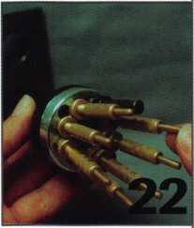

ALOA Bids Farewell

We honor the memory of a good friend and favorite instructor. Jim Rushing will be missed.

18

Convention 2000

See a recap of the ALOA Las Vegas Convention. It was one not to be missed.

By Patanya Johnson

22

The Science of Unlocking

The art of lock picking and its many techniques and tools. In most cases skill is more important than the tools used.

By Sal Dulcamara, CML

Sidewinder Ignition Drill

The problem of working on the Mercedes-Benz

ignition just might be solved with the use of

new tool.

By Donald B. Dennis, CPL

30

Higher Learning

The ALOA Scholarship Foundation is now accepting applications for scholarships to be awarded in 2001.

33

Your Untapped Sales Force

Any and all of your employees can be considered

a part of the sales force.

By Claire L Cohen, CML

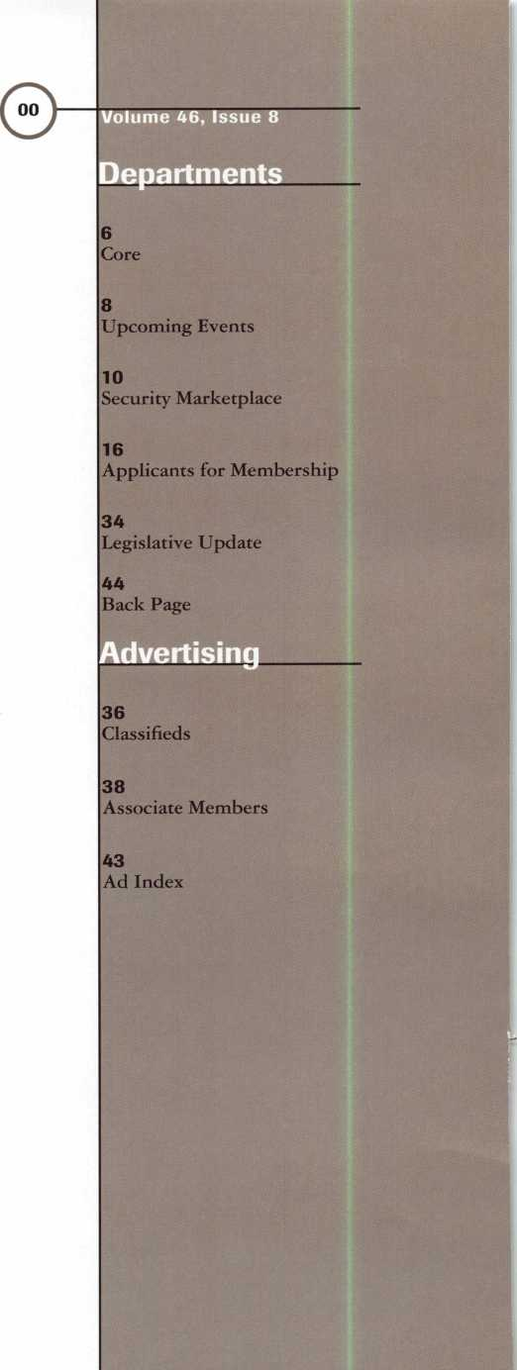

Art direction/design Phoenix Design 972.479.9026 ConQuest Graphixs 817.285.0003

2 | Keynotes September 2000

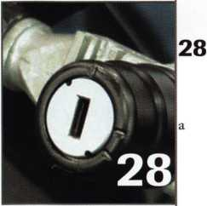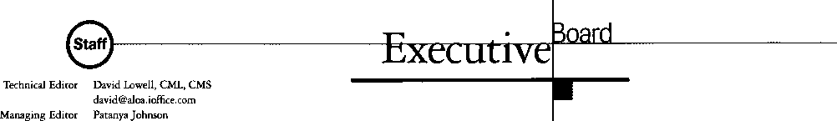

Editorial Advisor

Advertising Sales

Contributing Editors

Contributing Authors

John D. Cannon, CML

[jdcannon@worldnet.att.net](mailto:jdcannon@worldnet.att.net)

Marvin Diamond

Native American Journal Co.

(770) 993-3544

[thediamonds@mindspring.com](mailto:thediamonds@mindspring.com)

Paul Chandler, CRL

Claire Cohen, CML

Sal Dulcamara, CML

Jerome V. Andrews, CML

Brian Costley, CML, CMS

Bob De Weese, CPL

Ray D’Adamo, CML

Michael A. Ferrill

James Glazier, CML

Daniel Graffeo, CRL, CMS

Wayne Gurnee, CRL

A.J. Hoffman, CML

Ken Holmlund, CRL

Ray Lusk, CML

Mark Ohno

Randy Simpson, CML

Robert Stafford, CPL

Dave Thielen, CML

Additional contact information for the ALOA Board and most Keynotes authors is available through “Locksmith Search'” on the ALOA website- [www.aloa.org](http://www.aloa.org) or by contacting the ALOA office at 3003 Live Oak Street; Dallas, 7X75204; (800)532-2562;

FAX (214)827-1810; e-mail [aioa@aioa.org](mailto:aioa@aioa.org).

John J. Greenan, CML, CPS (773) 486-2030

Secretaiy

John D. Cannon, CML (703) 960-6413

Directors, Northeast

John C. Magee, III (856) 845-3434 Peter Sarailian, CRL (201) 994-7547 William L. Young, CML (610)) 647-5042

Directors, Southeast

Thomas W. Tate (850) 476-4211 Donald E. Rul6, CML (601) 324-2658

Directors, North Central

Mark E. Blum, CML, CPS (517) 482-5809 Tom Ripp, CRL (608) 262-3831

ALOA Professional Staff Executive Director

Operations/Membership Manager

Membership Coordinator Mail Room Coordinator Comptroller Accounting Coordinator Government Affairs Manager

PRP/Education Manager

PRP/Education Coordinator Conventions/Meetings Manager

Charles W. Gibson, Jr., CAE

[charlie@aloa.org](mailto:charlie@aloa.org)

Mary May

[mary@aloa.org](mailto:mary@aloa.org)

Shelly Jett

Trey Paris

Kathy J. Romo

Kathy Stokes

Tim McMullen

[tim@aloa.org](mailto:tim@aloa.org)

David Lowell, CML, CMS

[david@aloa.org](mailto:david@aloa.org)

Ashley Spencer

LaDana T. Houser

Meeting Coordinator Thom Terry Chapters & Regional Associations Liaison Tim McMullen [tim@aloa.org](mailto:tim@aloa.org)

Information Systems Manager Randy McChristian



Mission Statement: The Associated Locksmiths of America, Inc. is dedicated to enhancing the professionalism, education and ethics among locksmiths and those in related sectors of the physical security industry. With approximately 10,000 members in the United States, Canada and the freeworld, ALOA is poised to help members obtain the knowledge, the strength, and the confidence to perform their role in the physical security field with pride and dignity. But it is only through active involvement and participation that ALOA can fully achieve its potential-and can help members to achieve theirs.

Policies: Keynotes® is the official publication of the Associated Locksmiths of America, Inc. (ALOA). Keynotes® acts as a moderator without approving, disapproving, or guaranteeing the validity or accuracy of any data, claim, or opinion appearing under a byline or obtained or quoted from an acknowledged source. The opinions expressed by the authors do not necessarily reflect the official views of ALOA. Also, appearance of advertisements and new products or service information does not constitute an endorsement of products or services featured by the Association. The Association does not accept responsibility for the inaccuracy of any data, claim, or opinion appearing in this publication, due to typographical errors on the part of the authors, Association staff or its agents. Editor’s Note: This publication is designed to provide accurate and authoritative information in regard to the subject matter covered. It is provided and disseminated with the understanding that the publisher is not engaged in rendering legal or other professional services. If legal advice and other expert assistance is required, the services of a competent professional should be sought.

Authors’ Payment: Payment for eligible submissions to Keynotes will be based on the following criteria: topic, time spent and past contributions. Authors who regularly submit to Keynotes are generally paid a higher rate. The latter is especially true of authors who write to fit specific editorial needs and submit said copy by Keynotes deadlines. As a general guideline: Average payment for a 750 word, business or ‘light’ technical article would be $200. Payment for a 1500 word article involving significantly higher time and research efforts would be $400.

Payment will not be offered for articles submitted by ALOA employees or members of the ALOA Board of Directors (unless material is of a technical nature), nor for articles submitted by a company that promote that company’s products or services. ALOA reserves the right not to pay for articles submitted by an individual® that promote a particular company’s products or services.

Disclaimer: The Associated Locksmiths of America, Inc., (ALOA), reserves the right to refuse any article for any reason. Additionally, ALOA reserves the right to edit, amend or modify any article submitted for publication in order to preserve technical accuracy, clarity, fairness or grammatical correctness. ALOA will make the best efforts to notify the author of any changes. The extent of ALOA’s liability for any article or information contained therein will be a notice of correction or retraction in the next possible issue.

Keynoted (ISSN 0277 0792) is published monthly except for the combined June/July issue by The Associated Locksmiths of America, Inc., 3003 Live Oak St., Dallas, TX 75204-6186. Telephone: (214) 827-1701; FAX (214) 827-1810; e-mail [aloa@aloa.org](mailto:aloa@aloa.org). Subscription rates for members-$15.00 per year. Second class postage paid at Dallas, Texas. POSTMASTER: Send address changes to: Keynotes, 3003 Live Oak St., Dallas, TX 75204-6186. © Copyright 1999, All rights reserved. No part of the contents may be reproduced or reprinted in any form without prior written permission of the publisher.

Director, South Central

Randy L. Simpson, CML (713) 780-7026

Directors, Southwest

Gordon R. Racine, CML (719) 384-4707 John A. Ilk, CRL (602) 420-2174

Director, Northwest

Scott L. Henke, CRL, CPS (907) 248-3785

Director, Associate Members

David F. Matthies (727) 541-5536

Trustees

Dallas Brooks

(334) 826-8990

David M. Lowell, CML, CMS

(800) 532-2562

Breck H. Camp, CML

(770) 455-6244

Edwin Toepfer, RL

(416) 225-5589

Past Presidents

1997-1999 Dallas C. Brooks 1995-1997 David Lowell, CML, CMS 1993-1995 Breck Camp, CML 1991-1993 Henry Printz, CML 1989-1991 Evelyn Wersonick, CML, CPS 1987-1989 Leonard Passarello, CPL 1985-1987 Joe Jackman, CML 1983-1985 Stanley Haney, CPL 1981-1983 Louis LaGreco, CPL 1979-1981 John Kerr, RL 1977-1979 Clifford Cox, CML 1974-1977 Charles Hetherington 1972-1974 Gene Laughridge 1970-1972 William Dutcher, RL 1968-1970 Constant Maffrey, RL 1966-1968 Harold Edelstein, RL 1964-1966 William Meacham 1962-1964 Robert Rackliffe, CPL 1960-1962 Edwin Toepfer, RL 1956-1960 Ernest Johannesen

September 2000

Keynotes ii

with John j. Gmenan

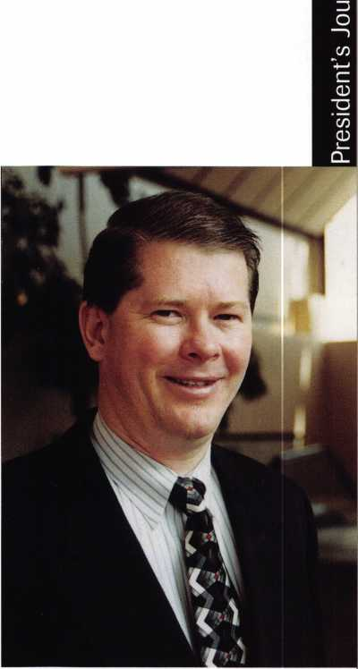

Approximately 5,000 people attended the ALOA 2000 Security Expo in Las Vegas, Nevada this year. It was one of the most informative Expos ever as well as being one of the most entertaining. Educational classes were held each day throughout the week. And, of course, the trade show itself afforded an excellent opportunity to learn with numerous exhibits of “tools of the trade.” Time spent on the floor was time well spent. And last but not least, the chance to interact with our colleagues, exchanging experiences, problem solving solutions, etc. was perhaps one of the most educational of all. See page 18 for a complete rundown on the Convention. Plan to attend the ALOA 2001 Security Expo in Baltimore, Maryland on July l6-22th.

Please note there will be a new look for Keynotes in the October issue. Our design staff is experimenting in new ways to present information to its members. As always comments and suggestions are welcome. Remember your participation in your Association is essential.

The ALOA Fall Board Meeting will be held October 13-15, 2000 during the SERLAC Convention in Jacksonville, Florida. This is an excellent opportunity to attend both functions. For information on SERLAC contact James Riley at (941) 294-8679.

John J. Greenan, CML, CPS

4

September 2000

Keynotes

175 101 93 _ 66_ 65_ 64 . 62 _ 51_ 48 _ 40 _ 38 _ 37_ 33 _ 32 _ 31_ 31_ 30 _ 29 _ 26 _ 24 _ 24 _ 24_ 24 _ 24_ 23 _ 23_ 23 _ 22 _ 21_ 21 _ 21 _ 21 _ 21 _ 20_ 19 _ 18 _ 18_

18

18_ 18_ 17 _ 17_ 17 _ 16_ 16_ 16 _ 16 _ 16 _ 15 _ 15 _

Toshihiro Asano

Henry Raymond

Stewart Levine, CML

.Charles Robertson, CML Mary Ohmit, CPL

.Jack Allen Konrath

.Salvatore Dulcamaro, CML

Myeong-Rae Cho

William Neff, CML

David Lowell, CML

.Thomas Freehling, CML

Dana Barnum, CML

John Heckman, CML

Jeanne Lodge, CML

Barry Leas, CRL

J Thomas Hood, CML

Danny Rudd, CPL

John Elliott, CML

Larry Warnick, CML

Roy Renderer, CML

Jim Williams, CRL

James Watt, CML

Robert Carroll, QPL

Robert DeWeese, CPL

Diana Barnum, CRL

.Anthony Ramunno, CML

Jerome Cohen, CML

David M A Federico

Eugene Altobella

William Lee

Elvis Hammerschmidt, CPL

Marian Swann, CRL

John Shandy, CML

John Dorsey, CML

D Michael Lee, CPL

James Fowler, CML

David Harris, CML

Keizo Takahashi, CRL

Ronald Heidzig

Philip Rovenolt, CPL

Lawrence Smith, CML

Joseph Ferrero, CML

James Cawby, CML

Michael Robinson, CRL

Brian Reetz

Walter Lascar, RL

.Thomas Vandersteen, CML

►lightest

Ip m

The Best.

.William McElheney, CML

Robert Duman, CML

Russell Fuller, CRL

Rex Parmelee, RL

James Gruber, CRL

James Brickler, CRL

Michael Groves

Daniel Landry

Edwin W Scott

_Peter Gauthier, CPL .Frank Hartung, CML Jon Griswold, CML

Paul Souber

Richard Sievers

Joe Lee, CRL

Steven Spiwak, CRL

_Robert Rodocker, CRL .Keiryu Tsukishiro, CRL Rolando Bouza

.Lonnie McKinney, CML

John Engel, CRL

Donald Shiles

Eric Veal

.Herbert Dusenberry, CML

Raymond Lusk, CML

Dale Knowles, CPL

Robin Horsley

Thomas Demont, CML

Ernest Wright

.William Wickward, CML Lester Brodsky

.Joseph Whitaker, CPL James Hawley, CRL

How can I join s Club?

You can earn membership in this prestigious club by recruiting just 10 new members for ALOA.

*Any ALOA member may participate.

What do I get?

When you recruit 10 members, you receive a handsome blue blazer with a President's Club crest. For each additional five members you recruit, you receive a lapel pin with gold-filled numbers, indicating your recruiting successes.

You also get the satisfaction of knowing that you are helping your association, helping your industry grow, and you are helping fellow locksmiths achieve success.

How do I get started?

Contact the ALOA office for a supply of applications (800) 532-ALOA or FAX (214) 827-1810. One President's Club credit is awarded for each new applicant. Credit is awarded only after the membership application is approved. However, the credit will apply for the period in which the application is received. Failure to identify yourself as the sponsor on the application form at the time it is submitted to ALOA for processing will forfeit any credit.

*AL0A Board of Directors not eligible for membership in the President's Club.

September 2000 Keynotes

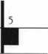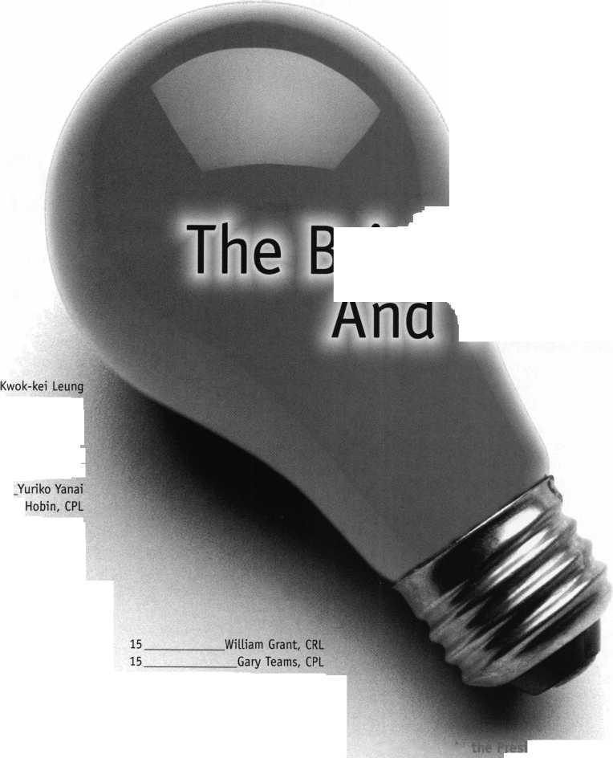

•SAINTS Wins Award

SAINTS (Safety, Awareness & Independence Now Through Security) Foundation has been awarded the Organization of Excellence “Superstar” Award by the Greater Washington Society of Association Executives (GWSAE). The SAINTS program was chosen because of the good will shown to the various communities affected by tragic church fires.

The award was presented to SIA Executive Director Ron Spiller at GWSAE’s Annual Meeting and Luncheon on July 11. SAINTS partners include the Security Industry Association (SIA), the American Society for Industrial Security (ASIS), the Central Station Alarm Association (CSAA), the International Association of Professional Security Consultants (IAPSC), the National Burglar &

Fire Alarm Association (NBFAA) and ALOA.

Other awards received by the program includes The American Society for Association Executives’ (ASAE) Award of Excellence in the 2000 Associations Advance America Awards Program and ASAE’s most prestigious award, the 2000 Associations Advance America Summit Award.

The SAINTS program was originally formed as an industry partnership with the Congress of National Black Churches (CNBC) that donated burglar, fire alarm systems, locks and monitoring to churches being rebuilt after arson fires burned them.

The SAINTS program has evolved in to a foundation and will continue to move forward with other community efforts.

* Golden Bear Lock & Safe Expands

Golden Bear Lock & Safe Inc. has broken ground on a new 6,000 square foot warehouse/retail showroom. The new facility is located at 7445 Daron Court, off Industrial Parkway and Post Road, near Dublin, Ohio.

* Briefs

An investigator in the Metro Atlanta area is looking into the theft of $80,000 in TESA brand stand-alone card readers. Apparently he has information indicating that the readers may be sold to someone in the lodging industry in South Carolina. If anyone has information concerning these readers, please contact:

Norred Associates, Inc.

Carter Schoenberg, Director of Investigations (404) 761-5058 Ext. 124 (404) 742-3993 fax [Cschoenberg@norred.com](mailto:Cschoenberg@norred.com)

6 I KeynotesSeptember 2000

n n r r

Congratulations to David F. Matt hies of Southern Lock & Supply Co in Pinellas Park, FI. Matthies is ALOA’s latest board appointment. He replaces Judd Penske of Meilink as the Director of Associate Members.

• Regions

The Greater Philadelphia Locksmiths Association

will be having their 50 + 1 Golden Jubilee on September 20-24, 2000 at the Philadelphia Airport Renaissance Hotel.

If you need more information contact Nelson Dayton at

(610) 688-9188.

The California Locksmith Association will begin it’s Apprenticeship Training Program on September 7,

2000 at 6:30 pm and subsequent Thursday nights. New students should show up at 6 pm at Grah Safe & Lock, 1049 Island Avenue in downtown San Diego.

The Gateway Locksmith Association will hold it’s Board of Directors Meeting on September 6, 2000 at 7 pm at IDN Hoffman, Inc., 1235 Research Blvd.,

Creve Cour, MO. Anyone wishing to attend is welcome.

For more information call (314) 692-839T

Missouri-Iowa-Nebraska-Kansas (MINK) Annual Educational Seminars hosted by The Missouri-Kansas Locksmith Associations will be held at the Holiday Inn Sports Complex in Kansas City, MO on September 28-30, 2000.

The Association of Ontario Locksmiths (TAOL) will hold it’s 27th Annual Convention September 8-10, 2000.

The Locksmith Association of San Antonio (LASA) held a Safe Opening Class on June 24th, which was taught by Keith Knot.

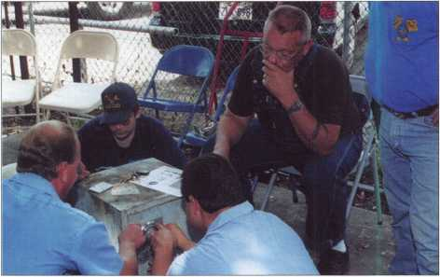

Safe Opening Class held in San Antonio, Texas

Safe Opening Class held in San Antonio, Texas

• PRP

• EXECS

ALOA would like to congratulate the following individuals who have recently achieved PRP designations.

CRL

Gary Hardiman, Dallas, TX Jeffrey C. Reese, Honesdale, PA David Rible, Bricktown, NJ

Wade Sawyer, Albuquerque, NM William Williams, Aston, PA

CPL

David A. Firestone, Middletown, PA

• Obits

ALOA bids farewell to Jim Rushing

ALOA ACE Instructor and longtime member Jim Rushing passed away Tuesday, June 20, 2000 at WK-Greenwood Road Hospital in Bossier City, LA.

He was 64 years old. For full story see page 15.

Matthew T. Farrell has been elected to the new position of vice president, investor relations and communication at Ingersoll-Rand Company, Kim McDonnell has been promoted to group communications manager at DORMA Architectural Hardware and Leo Mojica has accepted the position as controller for The Greater Alarm Company, Inc.

Recently ADI promoted Joe Cappelletti to executive vice president and general manager and Bill Lane to vice president of Structured Cabling. Sargent & Greenleaf’s Arm-A-Door Division has named Jeff Waufle as its new regional sales manager. Brinks Home Security, Inc. announces the appointment of Perry Adams as director of planning and analysis.

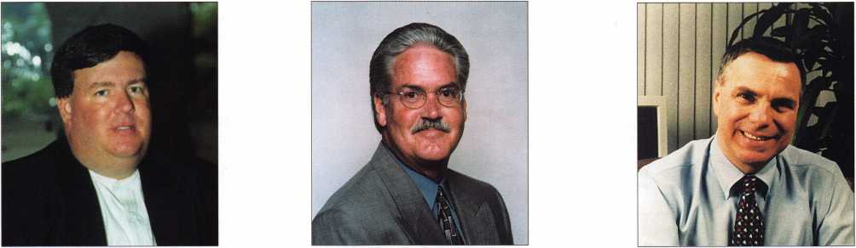

Bill Lane *Jeff* Waufle Joe Cappelletti

September 2000

Keynotes

Upcoming

Events



Deptl

Indicates ALOA ACE Class 0^ Indicates PRP Sitting

SEPTEMBER

1. 9

DHI Convention San Francisco, CA Contact: Kathy Devey (703) 222-2010

8

P ALOA PRP Sitting Dallas, TX

Contact: Ashley Spencer (214) 827-1701 (214) 827-1810 fax

1. 10

TAOL 27th Annual Convention Toronto, ON Canada Contact: DonDeKuyper (416) 321-2219 (888) 272-8265

8-10

Ace Classes Gulf Shores, AL

Alabama Locksmith Association Contact: Dallas Brooks (334) 826-8990

10

^ Ace Classes Meriden, CT

Nutmeg Chapter of ALOA Contact: Roger Wechter, CPL (203) 845-8700

1. 14

ASIS Convention Orlando, FL (703) 522-5800 [www.asisonline.org](http://www.asisonline.org)

15-16

SAVTA Fall Board Meeting St. Louis, MO

16

Distributors Show Eureka Springs, AK

Ozark Professional Locksmith Association Contact: Betty Gray (501) 524-3660 (918) 427-1066 evenings

17

^ ALOA PRP Sitting Burbank, CA Clark Security Products Contact: Ron Cooling (858) 974-5273 (858) 974-5284 fax

20-24

GPLA **50+1** Convention ALOA PRP Sitting Philadelphia, PA Contact: Nelson Dayton **(**610**)** 688-9188 [www.gpla.org](http://www.gpla.org)

23

Ace Classes

Professional Bypass Techniques Grand Canyon Chapter of ALOA Contact: John Ilk (480) 967-1876

1. 30

MINK Convention & Trade Show

^ ALOA PRP Sitting

Kansas City, MO

Royals Stadium Holiday Inn

Missouri-Kansas Locksmith Association

Contact: Bob Turner

(816) 525-5522

(816) 525-8628 fax

1. Oct 1

National Trade Show & Educational

Seminar Scarborough

Jo-Van Distributors Inc. (Toronto)

(416) 752-7249 (888)752-7210

OCTOBER

i

1 ITh Annual Locksmith Flea Market Hayward, CA

San Francisco Bay Area Chapter of CLA Contact: Blaine Lucas, CML, CPS (510) 278-2583

5-7

Lou-Miss Fall Convention ALOA PRP Sitting Lou-Miss Locksmith Association Contact: Donald Rule, CML (662) 574-3277

7

Servicing Hollow Metal Doors and Frames Casper, WY

Wyoming Locksmith Association Contact: Gene Ficek (605) 642-4542 (605) 642-8946 fax

7

28th Annual Lock Collectors Show Terryville, CT Lock Museum of America Contact: Geri Stuttig (203) 869-6260

1. 15

SERLAC

Ace Classes (8 Classes)

+ ALOA PRP Sitting Jacksonville, FL Contact: James Riley (941) 294-8679 Contact: Larry Patten, CPL (800) 845-5294 Contact: Austin Curry (800) 845-5294

13

^ ALOA PRP Sitting Dallas, TX

Contact: Ashley Spencer (214) 827-1701 (214) 827-1810 fax

1. 15

ALOA Fall Board Meeting Jacksonville, FL

14

ALOA PRP Sitting Colorado Springs, CO Central & Southern Colorado Locksmith Association Contact: Rick Dyer, CRL (719) 282-0360 (877) 694-6011 fax

21-22

Ace Classes

Master Keying Methods & Formats Fargo, MD

Curtis Lock & Key Svc., Inc.

Contact: Todd Lad wig, CML (701) 232-9440

22

jj4* ALOA PRP Sitting Ohio Valley Chapter of ALOA Dayton, OH

Contact: William Lockwood, CPL (937) 836-6127

24-28

ALOA PRP Sitting Tri-Regional Show Bellevue, WA Contact: Chuck Pigue (360) 396-6073 Contact: Larry Bomstead (253) 926-3000

28-29

Educational Classes

Investigative Locksmithing I & II

Houston, TX

University Hilton Hotel

Greater Houston Locksmiths Association

Contact: Judy Clifford

(979) 297-2413

Bill Dodson

(409) 588-2823

***Keynotes***

September 2000

NOVEMBER

1-5

Yankee Security Convention Ace Classes (15 Classes) fk ALOA PRP Sitting Sturbridge, MA (800) 209-8266 Contact Robert Mahoney (860) 643-6922

10

^ ALOA PRP Sitting Dallas, TX

Contact: Ashley Spencer (214) 827-1701 (214) 827-1810 fax

11

^ ALOA PRP Sitting Raleigh, NC

North Carolina Locksmith Association Contact: Granger Marley, CML (919) 859-6060

18

15 th Anniversary Banquet Grand Canyon Chapter of ALOA ALOA PRP Sitting Contact: Bob Arthur (623) 848-0685 Contact John Ilk (602) 574-3277

19

^ ALOA PRP Sitting Honolulu, HI Clark Security Products Contact: Ron Cooling (619)718-7301

DECEMBER

8

ALOA PRP Sitting Dallas, TX

Contact: Ashley Spencer (214) 827-1701 (214) 827-1810 fax

2001

FEBRUARY

3

Ace Classes

Electronic Safe Lock Class Alabama Locksmith Association Contact: Dallas Brooks (334) 826-8990

6-11

2001 Annual Convention & Trade Show Austin, TX

Omni Austin Hotel Southpark The Texas Locksmiths Association Contact:

Registration: Jim Hetchler (380) 606-1727 Exhibits: Robert Hernandez (210) 433-5397 General info: Judy Clifford (979) 297-2413

MARCH

23-25

ALOA Spring Board Meeting Dallas, TX

28-April 1

MLANJ 2001 Annual Convention

**fcr\** Ace Classes

^ PRP Sitting

Somerset, NJ

(973) 267-8884

(973) 538-2248 fax

[www.mlanj.org](http://www.mlanj.org)

April

30-May 5

SAFETECH 2001 St. Louis, MO (214) 827-7233

JULY

15-22

ALOA 2001 Security Expo Baltimore, MD (800) 532-2562

Oct

15-21

Tri Regional Locksmith Conference Portland, OR

Pacific Locksmith Association Contact: Stan Hauer (503) 325-7334 Email [hauer@pacifier.com](mailto:hauer@pacifier.com) Contact: Ken Mead (503) 873-6932

2002

JULY

22-28

ALOA 2002 Security Expo Rosemont, IL (800) 532-256

TURPI lO

**WHOLESALE SERVICE**

800-848-9790

One Call  
Gets You...

Amsec

e

Gardall

e

Hayman

Meilink

Victor

e

Winchester

Plus Free Delivery  
From America's  
Largest Inventory  
of Safes.

**September 2000** **Keynotes**



Security

Marketplace

Marks USA

Marks USA introduces its ANSI grade 1 and 2 Survivor series key-in-lever cylindrical locksets in two lever designs. The “American” design has an

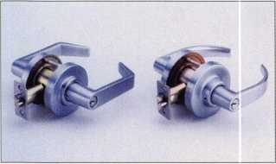

angular return and the “Crescent” has a smooth rounded lever. Both designs feature a clutch mechanism which prevents forced entry and damage to the lock by disengaging the lever from the lock before damage can occur.

Marks locksets feature a lifetime mechanical warranty. All Survivor locksets are UL Listed for 3-hour fire rating and satisfy all ADA requirements. Marks USA

5300 New Horizons Blvd.

Amityville, NY 11701 (631)225-5400 (631)225-6136 fax

NAPCO Security Group

NAPCO introduces 2-Way Universal LCD Keyfob. The keyfob is the industry’s first universal bi-directional keyfob with an LCD status display. It is compatible with most major control panels. System status is indicated in two ways: visually on the LCD icon display, and audibly with beep

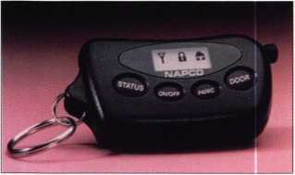

sequences. The screen displays eight icons, they include a house, lock and flame, along with other symbols, plus a “Stay and Away” mode. The 2-Way Keyfob features rolling code and panic. With the keyfob you can control two

Keynotes September 2000



groups of lights, and up to two garage doors. The 2-Way Keyfobs are sold in a kit (2Way-UNIVKFKIT), which includes a receiver that supports up to seven keyfobs.

NAPCO

(800) 645-9445 Ext. 64

KNAACK Manufacturing Company

WEATHER GUARD(r) Truck and Van Equipment introduces Jumbo Van Shelving for walk-in style vans and trailers. Now available in either 433/4” tall or Extra tall 591/2” heights, these

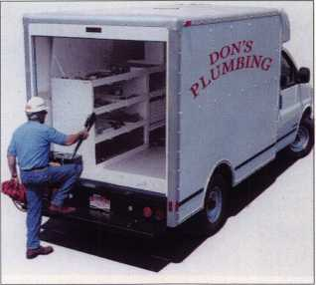

taller shelves are extra deep. Ranging from 14” to a full 24”, they are designed to fit walk-in vans, cube vans and step vans. The 18 gauge steel with 3” retainer lips add rigidity for extra strength. Each shelf unit is sealed with a high grade hybrid polyester powder coating. The WG-Ti(r) Brite White Finish brightens up the interior for good visibility. All WEATHER GUARD(r) Products are backed by a two year warranty covering defects in material and workmanship.

KNAACK

420 E Terra Cotta Ave Crystal Lake, 1L 60014 (800) 456-7865

www. weatherguard. com

Access Hardware Supply

The H.E.S. surface mounted 9600 Genesis electric strike is now available from Access Hardware Supply. The 9600 requires no cutting of the doorframe. The faceplate encases all the

Electro-mechanical components. It also accommodates rim mounted panic exit devices and can be installed on metal, wood or aluminum jambs. The 9600 is field selectable 12V or 24V AC/DC. Optional latch bolt monitor and latch bolt strike monitor that indicates the position of the latchbolt and the locked or unlocked condition of the electric strike.

A.H.S.

14359 Catalina St.

San Leandro, CA 94577 (800) 348-2263 (800) 435-8233 fax www. accesshardware. com

Palmer Security Products

Palmer Security introduces the Model 5000PB Firearms Drawer Safe. The drawer safe offers the following benefits: a Simplex quick-access lock for speedy entry-no batteries required; combination can be reset anytime; custom four-bolt locking system for exceptional security; bolts to any

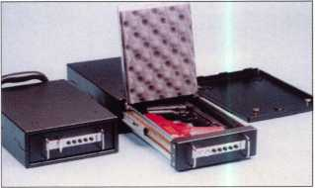

horizontal surface, mounting holes provided; pry-resistant 12 and 14 gauge steel construction; a lined interior to protect valuables; carrying handle; optional mounting frames allow quick lockdown and removal, and a two handgun capacity.

Palmer Security Products (800) 788-7725

[www.palmersecurity](http://www.palmersecurity), com

Audio Video Supply

Audio Video Supply has launched the B-01 high-performance black and white CCD 1/3” Sony Image Sensor camera. It is available in either a 3.7 mm pinhole lens or the optional board camera with a built-in 3.6 mm lens. Its compact and unobtrusive. The B-01 is

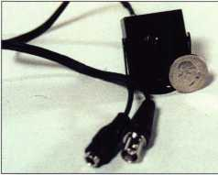

equipped with a casing and mounting bracket made of durable black aluminum. It delivers at a high resolution with full image quality and operates on a 12 Volt DC power supply. Audio Video Supply (800) 284-2288 (858) 565-7845 fax prodinfo@avsupply. com [www.avsupply](http://www.avsupply). com

Secure Key

The Radio Key( RK-WL long-range proximity reader is now available. It comes with a list price of $404 and a read range of up to three feet, this

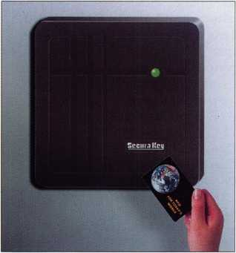

Wiegand output reader may be connected to access control and telephone entry systems by most manufactures. The RK-W1 provides excellent protection against weather and may be mounted on virtually any flat surface or electrical box. Patent- pending Dynascan(r) technology assures maximum reader performance in any environment.

Secura Key 20447 NordhoffSt.

Chatsworth, CA 91311 (818) 882-0020 (800) 891-0020 (818) 882-7052 fax www. securakey. com

Dortronics Systems Inc.

Dortronics offers a compact magnetic lock with 1200 pounds holding force. The 1000 Series, features a compact enclosure and universal mounting. The 1000 Series electronics are epoxy sealed

within a stainless steel housing to provide protection from the elements. The housing, armature and exposed face of the lock are Electro plated to resist rust and corrosion. The unit is supplied with an adjustable mounting plate for use on out-swing doors. Any 1000 Series lock can be converted in

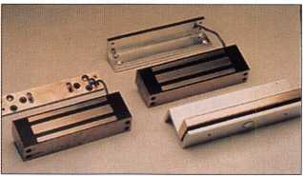

the field for in-swing doors. An optional conduit fitting is available for gate installations. In addition, the 1000 Series operating voltage is field selectable and may operate on 12 or 24V DC. Only 170ma at 24V is required to maintain the rated 1200 pound holding force.

Dortronics (800) 906-0137 sales @dortron ics. ocm [www.dortronics.com](http://www.dortronics.com)

Pana Vise Products

Panavise introduces the Deluxe Micro Mount for smaller cameras. It has two mounting options: a round foot or a T- Bar clip. The 1/2-inch steel shaft has

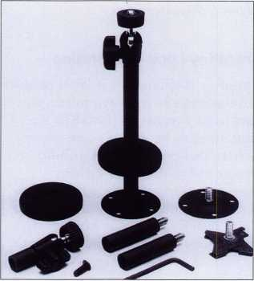

three segments for 2”, 4” or 6” overall lengths. The mount includes both a knob or set-screw adjusting options and the knuckle assembly has an easy-to-use lockring and a 1/4-20 male stud. The Deluxe Micro Mount is available in black (Model No. 845-246) or cream (Model No. 845-246W).

Pana Vise Products 7540 Colbert Dr.

Reno, NV 89511 (775) 850-2900 (775) 850-2929 fax [www.panavise](http://www.panavise). com

Emhart Fastening Teknologies

Emhart has announced the availability of the POP( Powerlink 30 Rivet Tool Kit. The kit comes with the Powerlink 30 rivet tool and 200 of Emhart s POP(brand blind rivets and rivet washers packed in a plastic case. The tool has the ability to set rivets up to 3/16”. The other nose pieces make it capable of setting 3/32”, 1/8” and 5/32” rivets. The nosepieces and wrench to change them are stored in the handle, which is designed to allow one-hand operation, while eliminating pinch points.

Emhart 510 River Rd.

Shelton, Conn. 06484 (203) 925-3176 (203) 925-3109 www. emhart. com

Videx

Videx recently announced CyberLock, a lock cylinder designed to convert existing mechanical locks into full functioning access control systems. The

CyberLock system consists of the CyberLock cylinder and the CyberKeyG The cylinder contains a microprocessor and memory, has exactly the same dimensions as a standard 6-pin mechanical cylinder. It can usually be installed in less than 10 minutes in tubular knob sets, lever locks, rim locks and mortise locks in doors; as well as locks in cabinets, drawers, storage containers and padlocks. The CyberLock cylinder doesn’t contain a battery, the access privileges and battery power is located in the CyberKey. Each time a key opens a lock, a record is stored in both the key and the cylinder, creating a lock history and a key history. The CyberKey will hold up to 1150 events and the CyberLock cylinder will record the last 1100 events. CyberLock can be installed wherever controlled access and audit reporting is beneficial.

Videx

(541) 758-0521 (541) 752-5285

sales @ videx. com www. videx. com

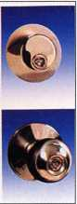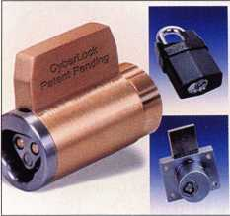

September 2000 Keynotes

Security

Marketplace



Dept]

RSR Group Inc.

RSR is offering a portable electronic security safe for transporting and storing valuables. Mossberg’s InstantA- ccess( can store valuables while giving you quick convenient access. The safe is compact, portable and easily fits in a dresser or desk drawer. The safe comes complete with a tamper-proof, galvanized steel mounting plate for installation, wherever permanent storage is required. The Portable Electronic Security Safe gives you immediate access. The cover opens automatically when you enter your 4- digit PIN code. It comes with a lighted keypad and lighted interior compart­ment. The safe is battery operated and features a tamper-proof alarm, that alerts when the incorrect code has been entered.

RSR Group (800) 925-4034

Master Lock Company

Master Lock introduces two new resettable combination padlocks to complement its popular No. 175 resettable combination padlock: . A solid brass lock with shrouded shackle

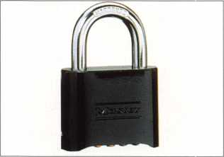

(No. 177), for maximum security against bolt cutters and shackle cut attacks and an economical die-cast (No. 178), which features an attractive corrosion-resistant powder coated case. Both offer the same direct dial, 10,000 possible combinations, and resettable features as the established No. 175. Master Lock PO Box 100367 Milwaukee, W1 53210 www. masterlock. com

Lockmasters Inc.

Lockmasters announces the addition of “Super” StrongArm Safe Drill Bits. These multipurpose drill bits have high grade, chrome-moly steel shanks that have been tempered for extra durability, titanium tungsten carbide tips, and an ultra high temperature copper braze which adds strength and reduces tip failure from over heating. Lockmasters stocks all diameters and lengths. Lockmasters Inc.

(800) 654-0637 (859) 885-6041

www. lockmasters. com

InstaKey Lock Corporation

InstaKey is offering their latest product brochure free to security professionals and facility managers. InstaKey is a customizable key-based access control system that provides the capability to re-key and re-pin locks without hardware changes or the services of a special technician. The four page, four color InstaKey brochure explains the key control program, which involves a

MasterLink Security Products

ROGER ALEXANDER-TUTTLE

understanding the needs of locksmiths...”

Mortise/Rim/Knob Cylinders • Storefront Door Hardware  
Cabinet Locks • Chain • Key Blanks • Padlocks • Pins ...and more

Local: (954) 730.9669 • Toll Free: (877) 347.9669

Fax: (954) 486.0575

e-mail: [masterlink@minclspriiig.com](mailto:masterlink@minclspriiig.com)

3863 NW 19th Street, Lauderdale Lakes, FL 33311

September 2000

patented method of removing stacks of wafers from the columns of a lock cylinder, one wafer at a time.

InstaKey Lock Corp.

(800)316-5397 www. I nstaKey. com

ATC-Frost Magnetics Inc.

ATC-Frost has introduced the FCS824 camera power supply that produces 24VAC for up to eight CCTV cameras. The enclosure, made of 11 ga. powder- coated steel and measuring 12’ x 12’, is low profile to fit into available space. It contains a fully rated 100VA power transformer with eight fused 24VAC outputs at 0.5A each. Also included is a front-mounted 24V LED indicator, spare fuses, eight 1/2” knockouts on the perimeter of the enclosure and separate terminal blocks for both inputs and outputs. The unit is ULC listed. ATC-Frost Magnetics Inc.

1130 Eighth Line Oakville, Ontario Canada L6H 2Z4 (905) 844-6681 (905) 844-6895 fax

eritter@ ate-frost, com

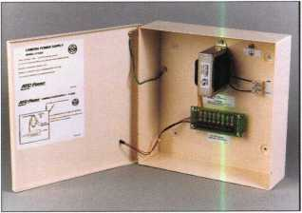

ADI

ADI announced the release of its first- ever Residential Structured Cabling and Networking Product Catalog. This comprehensive product guide is packed with more than 80-pages of products, product specifications and technical white papers from over 20 of the industry’s top manufactures. To request a free copy of catalog, call your local branch.

ADI

263 Old Country Rd.

Melville, NY 11747 (800) 233-6261

Keynotes



*Visit our Website on  
www. stamcctv. com*

THE COMPLETE

CCTV PROGRAM ON CD-ROM  
FOR STAFF TRAINING AND

PRODUCTIVITY ENHANCEMENT

STAM Insight has been

developed to enhance CCTV

skills and productivity with  
many different uses.

€1 Productivity

t# System Drawing  
**W** Estimation  
**#** CCTV Training  
CCTV Reference  
O Sales/Demo  
System Design  
I# Staff Evaluation

|  |  |  |  |  |  |
| --- | --- | --- | --- | --- | --- |
| i |  | CCTV Content  CCTV Calculators | XQtmm  / | , %m%mm r | 14 hours ' |
| %  a. |  | Demonstration Tool |  |  | f |
| f |  | Estimation | m | F*"  f'  f |  |
| jl |  | Drawing | m | f |
| & |  | Internet Enabled | m | f |
| Training | |  | Pre-Test | mmmm H  m | 1 &0 1  . i. . „ ^ | f |
|  | Quizzes  Knowledge Assessment | m  m | : _±  m | /  w |

**Sold in Over 50**



COPYRIGHT © 1996 Security Training and Marketing Pty Ltd.  
All rights reserved ACN 057 006 541

September 2000

Keynotes L

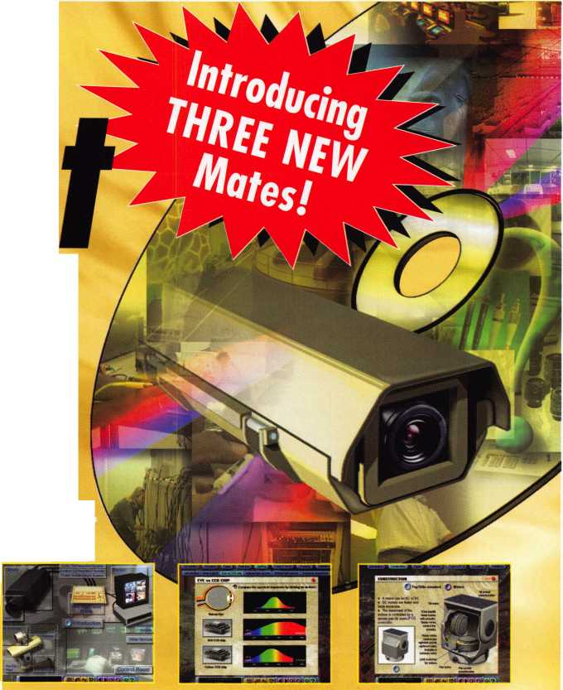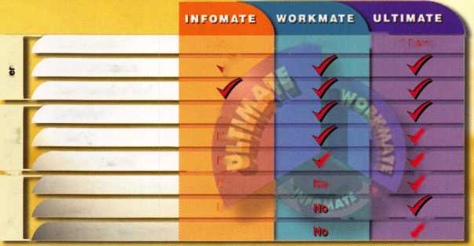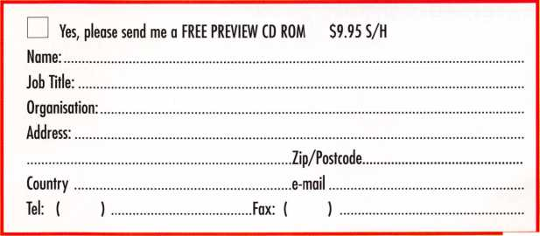

The Ultimate Trip...for Safe Technicians.

**Unlocking impenetrable monoliths is no mystery to you—you've been doing that your entire career. You've also witnessed your industry in a constant state of evolution.**

**To keep up with "what's out there" attend SAFETECH** 2001 **- April** 30 **- May** 5,2001 **in St. Louis. You'll appreciate the location—in one of America's most modernized cities, and the opportunity to explore the modernization of your industry. For more information call** 214**.**827**.**7233**, or email [convention@anet-dfw.com](mailto:convention@anet-dfw.com).**

**SAFETECH** 2001**-Shaping the future.**

**SAFETECH**

2001

A SAFE ODYSSEY



ST. LOUIS, MO

ALOA bids farewell to Jim Rushing

ALOA ACE Instructor and longtime member Jim Rushing  
passed away Tuesday, June 20, 2000 at WK-Greenwood Road  
Hospital in Bossier City, LA. He was 64 years old.

Jim was a member of ALOA for over 14 years and served  
as an ACE instructor for five years. Jim was a Certified Master  
Locksmith, and excellent instructor. He taught several  
different classes over the years at conventions, but most often  
it was Basic Locksmithing. He taught wherever and whenever  
he was asked to teach.

He owned and operated Barksdale Key and Lock Service  
since 1978. He was a member and Past President of the  
Texas Locksmith Association (TLA), Louisiana-Mississippi  
Locksmith Association (LOU-MISS), and Past President and  
a founding member of the Arkansas, Louisiana, Texas  
Locksmith Association (Ark-La-Tex).

He is survived by his wife Sheila, three children,

Debbie, Mark and Jimmy; sister Lenna; brother Harry;  
four grandchildren; one great-grandson, numerous nieces,  
nephews and friends.

“ALOA and the locksmith industry suffered a tremendous  
loss on June 20, 2000 with the sudden death of Jim Rushing,  
CML. Jim an ACE instructor was always willing to drop  
everything and teach whenever there were a few assembled  
locksmiths yearning for the knowledge and expertise that he  
possessed. Every time that I called to ask Jim to instruct at an  
ALOA ACE event he did so willingly and eagerly. Although  
he was knowledgeable about many subjects, he preferred to  
teach basic locksmithing to those who were starting out in the

profession. His untiring and unselfish dedication to the  
educating of locksmiths was unparalled. Jim will be sorely

missed by those whose lives he came in contact.” WM

David M. Lowell, CML,CMS ALOA Education!Proficiency Registration Program Manager

“With his own nickel, helping students with problems, he put on countless Road Show type classes in Texas, Louisiana and Mississippi. He could teach anything.

He was a true Master Locksmith. He was a remarkable person and a good role model for all locksmiths.

Jim was a favorite leader in Texas known for his good humor, wisdom, ability and willing personality. He could inspire a group of locksmiths to greatness and unity one minute, and have them rolling in the isles from his humor the next. Many of us have benefited from his efforts. It is to be hoped that others will take up the torch of caring, helping, leadership, educating and service to others, that he carried so well.

I shall miss him greatly, I hope his passing was gentle. Good-bye Jim, I will not forget you.”

“To have known Jim and witnessed his passion for teaching and love of locksmithing was a true blessing. Unlike some of my other friends in the industry, I was blessed with the opportunity over our many years of friendship to be witness to every side of this man; the sorrow of losing a beloved wife to a tragic accident, pride in his children, love for his grandchildren, his dedication and leadership as a locksmith, and passion for sharing his knowledge. He could crack you up with a joke, and entertain you with his wonderful “fishing” and “hunting” stories. I have also witnessed a private side of Jim along with the stubborn side, and I will always remain in awe of the way he handled both. I shall continue to treasure the many ways Jim touched my life.”

Judy Clifford

C.D. Lipscomb, CML, CPS

Keynotes

September 2000

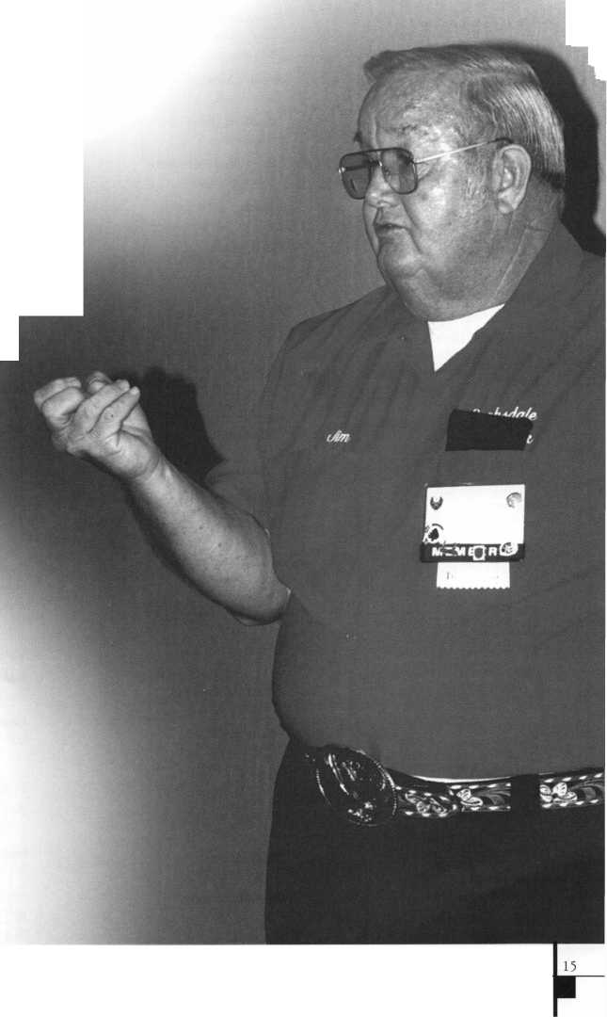

Applicants

For Membership

Dept

*The following applicants are scheduled for clearance as members  
of ALOA. The names are published for member review and comment  
prior to October 1,2000, respectively, to ensure applicants meet standards of  
ALOA’s Code of Ethics. Protests, if any, should be addressed to the  
Membership Department and must be signed. Active Membership applicants  
(A) have worked in the industry two or more years. Allied Membership  
(AL) applicants are not locksmiths, but work in a security-related field.  
Apprentice Membership CAP) applicants have worked in the industry  
less than two years. A*

|  |  |
| --- | --- |
| ALASKA | Riverside |
| Anchorage | Greg T Dengler |
| Ky A Hume | Rohnert Park |
| Tyler L Duncan | Michael G Egan |
| Junuea | San Bernardino |
| Justin H Burns | Harold S Hively  Earl Hively |
| ARKANSAS | San Diego |
| Hope | Burt Fieser |
| Chad Ayers | San Jose  Paul Nguyen |
| ARIZONA | James Ellis |
| Black Canyon City | Santa Barbara |
| Jacob Shelton  Chandler | Michael J Berteloot  Gail Roose |
| Alois Crepinsek  Mesa | Santa Clara  Steven Gollob |
| Gordon R McGee Sr | Sherman Oaks |
| William H Scott | Frank Flam |
| Parks | South San Francisco |
| David B Gaynor | Stephen Shields |
| Yuma | Visalia |
| Barry Waite | Doyle W Pope  West Hills |
| CALIFORNIA  Berkeley | Jerry Engelberg |
| Leonard S Vasaure | COLORADO |
| Capistrano Beach | Colorado Springs |
| Patrick Cunningham | Lloyd Seliber CML |
| Fresno | Denver |
| Maria Glover | Amanda Elston |
| Hesperia | Keystone |
| Tomas Garcia | Dottie Riotto |
| Lake Forest  Cuong Nguyen | Jim Clements III |
| Livermore | CONNECTICUT |
| Jeff Hendry | New Haven |
| Long Beach | Patrick Blatchley |
| Joseph W Contreras | Ridgefield |
| Los Gatos  Su X Nguyen | Mary E Schrag |
| Marysville | FLORIDA |
| Mitch McMullen | Branden |
| Oakland | Chris Hudson |
| Tim Howell | Deerfield Beach |
| Christine Lum | Mike Rose |
| Ojai | Islamorada |
| Lucy Martin | Lonnie B Rylant |
| Orange | Jupiter |
| James Noll | Edward W Sixberry CML |
| Palm Desert | Marianna |
| Kelvin R Meier CML | Don C Barber |
| Bruce Hagerman | Pinellas Park |
| Pasadena | Claude A Hensley |
| Michael Mason | Port Saint Lucie |
| Redondo Beach | Denise DiSalvo |
| Michael A Johnson | Kyle Chavious |

|  |  |
| --- | --- |
| GEORGIA | MINNESTOTA |
| Danielsville | Duluth |
| Philip P Croya | Nancy B Day |
| Stockbridge | Saint Cloud |
| Benjamin W Mitchell | Doug Jaeger |
| Bernard Mitchell | Chris Jaeger |
| HAWAII | Wabasha  Glen D Polyard |
| Hilo | |
| Hannah O’ Neill- Reyes | MISSISSIPPI |
| ILLINOIS | Gulfport  Elizabeth Necaise |
| Downers Grove | |
| Michael W Barrett | NEBRASKA |
| Sandwich | Nemaha  R D Christoffersen |
| Donald L Frederick |
| Warrenville | |
| David M Metz | NEW JERSEY |
| KANSAS  Douglas | Asbury Park  Angel M Lorenzana  Englewood  Walter McNair |
| Rod Berg  Kansas City | Morristown  Scott Honickel |
| Jim Peters  Overland Park | Neptune  Juan C Martinez |
| Steven L Conradt CRL | New Brunswick |
| Plains | Leroy J Linden |
| Terrance J Shinogle  Jamestown | NEW MEXICO |
| Aric J Blankenship | Albuquerque |
| LOUISIANA | Ronnie Rael  Randy Erwin |
| Ponchatoula | Farmington |
| Franklin D Rehm Jr | Wayne Wilkins |
| MASSACHUSETTS | Rio Rancho  Erick W Gallegos |
| Boston | |
| Richard Petraglia | NEVADA |
| Anthony Presutti | Las Vegas |
| MARYLAND | Byron K Staten Matthew M Black  Anthony J Spano |
| Baltimore | James Bright |
| Sean M Kling  Capitol Heights | NEW YORK |
| Curtis Sheelor  MICHIGAN | Bronx  Moshe Zlikha  Deer Park |
| Grosse Pointe Woods | Michael Pennino |
| Paul Spina | Yonkers |
| Holland | Jacob Halpert |
| Diane Broekhuis  Troy Albernathy | OHIO |
| Rochester Hills | Bucyrus |
| Dean E Robinson | William H Crabbs |

Keynotes

September 2000



Fort Loramie

Michael Busse

Independence

Bruce A Misko

Sandusky

Scott H Von Heldt

Carlton

Walter M Madsen Jr

Keizer

Chris Arnett

Salem

Mark T Roberts

PENSLVANIA

Hanover

Anthony W Reed

Harrisburg

Raymond Shaver

Horsham

Michael Opelski

Leola

Traci Carvell

Penfield

Larry D Knisely

Upper Darby

Lee Berger

TENNESSEE

Memphis

Lou Cosper Ron Swanson

TEXAS

Cotolla

Michael Johnson

El Paso

George Saucedo

Huntsville

Steven S Sandlin

Rowlett

Sam Showers

Tyler

John D Roberson

UTAH

Layton

Mitch Wolthoff

Spanish Fork

Lamar G Howarth

West Jordan

Steven J Hamann

VIRGINIA

Ashbum

Scott W Dibert

Falls Church

Robert Barton

McLean

John R Crump Jr

Woodbridge

Barbara A St Denis John M St Denis

WASHINGTON

Olympia

Matthew T Lebens

Tacoma

Jack B Wingerter CML

Vancouver

Michael L Guild

WISCONSIN

Milwaukee

Nancy Gentz Diane Gierach Patricia Neveaux Josephine E Woods Mary Staat

Sussex

Mary Gellendin

Waldo

Kenneth J Smith

Waldo

Jennifer Mason

AUSTRALIA

Kedron

Cameron N Moses

BULGARIA

Bourgas

Ivelin T Todorov

Sofia

Daniel G Atanasov Biser M Skilov George C Damianov

CANADA

Calgary Alberta

Jason Cenaiko

Monctur NB

Bruce W Martin

Winnipeg

Allan Poapst CPS

Langley BC

Steve F Copley

Vancouver BC

Eric Fillion

AB Edmonton

Calvin D Pereira

COSTA RICA

San Jose

Oscar Salazar Ricardo Munoz

FRANCE

Roubaix

Jean-Pierre Porquet

ISRAEL

Tel-Aviv

David Barzinzki

Hod Hasharon

Rami Rahamim Shmuel

Yaune

Eli Rodkin

Givat-zeev

Yigal Tobi

JAPAN

Arakawa-ku, Tokyo

Hiroyuki Okada

Chiba

Yoshihiro Furuya

Ehime

Taichi Mahi

Hiroshima-City Hiroshima

Hiroshi Handa

Kanazawa

Masaki Kato

Kasugai Aichi

Kei Ohshima

Kobe-City Hyogo

Okubo Hiroshi

Kochi

Koji Machida

Nagoya City Hichi

Haruo Hirai

Nagoya Hichi

Ryo Mitsuya

Tokyo

Irving Wiesel

Toshimaku - Tokyo

Chiaki Ogura

Tokyo

Kiyohiro Otsuka

MEXICO

Guanajuato

Refugio J Lara Ruiz

SINGAPORE

Wan Chuen Loh Kin Tsing Leong Kee Swee Aw Tan Hua-Seng Cheow Hock Tan

UNITED KINGDOM

Berkhamsted

Nick Mason

SECURITy

LOCK COMPANY

**New** Factory Replacement Parts and Locks for Security Corporation and Kumahira Safe Co. Products

* Safe Deposit Box Locks and Parts BX, KD
* Automatic Remote Tube Systems (ARTS)
* Drive Up Systems
* Vault Doors
* Night Depositories
* Camera Systems
* Key Blanks and
* Keys Cut to Code

KD Series

Safe Deposit Box Locks

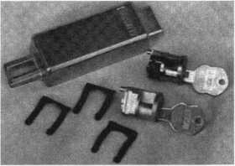

BX Series Safe Deposit Locks

1155 Chess Drive, #114 Foster City, CA 94404 Phone: (650)525-0660 Fax: (650) 525-0444

Email:

[chaslutz@securitylockco.com](mailto:chaslutz@securitylockco.com)

SECURITy

LOCK COMPANY

September 2000



Keynotes

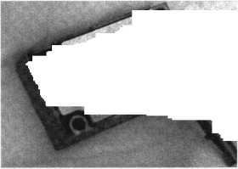

(From left) ALOA Board Members, John Cannon, CML; Gordon Racine, CML; Bill Young, CML; John J. Greenan, CML, CPS; Don Rule, CML and Randy Simpson, CML cut the ribbon to officially open the Security Expo.

i^ALOAit

by Patanya Johnson

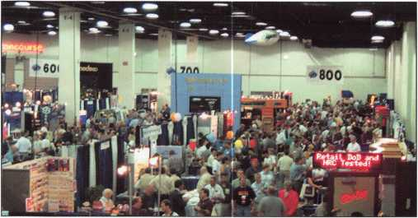

ALOA 2000 Las Vegas was an event to remember.  
Don’t just take our word for it. Look at the photos or ask  
anyone who was there.

ALOA 2000 was one of the best shows ALOA has  
had in years. Almost 5,000 people were in attendance at  
this year’s show. With that record number, the show was  
bound to be a success. Classes, seminars, meetings,  
Kick-Off Party, Dinner Banquet and the Security Expo

Tbm was much to see and learn at the 2000 Security Expo. were all well attended events.

The week was filled with 70 full-day and 36 half-day educational classes. These classes provided education, opportunity, skills and training for those taking them as well as those instructing. Once again certain electives of the Proficiency Registration Program exam were administered after designated classes. This gave students the opportunity to cover the material in class and take the exam on the same day. Those that took advantage of the classes being offered walked away with better education, increased skills, hands-on training, and for some, another level of certification. ASSA has chosen to use ACE Certified

Attendees visit the ALOA Membership Booth.

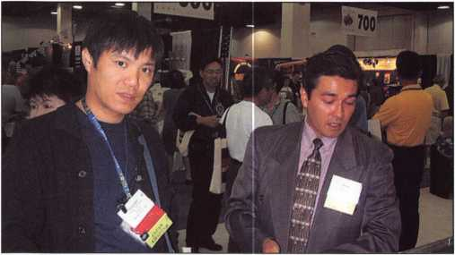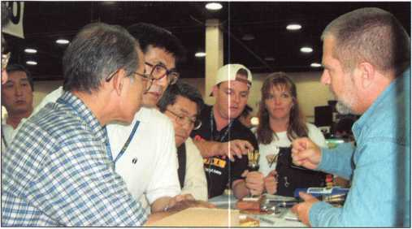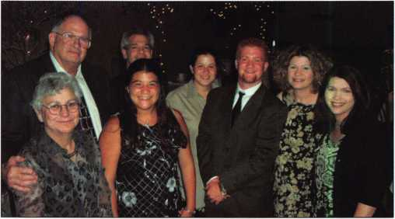

Ken Pearson of Locksmasters, demonstrates his company's product as Hide Kimura, Masaik Kato , Rick and Laura Milliorn look on.



Keynotes

September 2000

The Hoffman Family pose a moment for the camera at the Dinner Banquet.

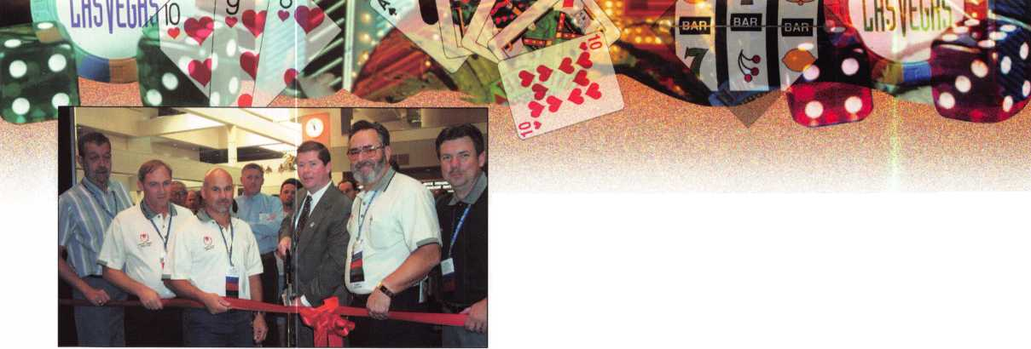

Instructors to conduct all ASSA Factory Certifications. ALOA 2000 gave the ACE instructors the opportunity to go through the training and certification of ASSA.

The 15 th Annual ALOA Open Golf Tournament was held at the Angel Park Golf Club in Las Vegas.

Over 80 of ALOA’s finest golfers joined Yale Security, the event sponsor, on the green for 18 holes of golf. The top winners were Dean Cairns, Mens Low Gross; Jeff Beckman, Men’s Low Net; Francis Watanabe, Women’s Low Net; and Linda Wood, Women’s Low Gross. Yale presented the Scholarship Foundation the proceeds of the tournament, a check in the amount of $11,500.

The annual Kick-Off Party followed by the first-ever Live Auction, was co-sponsored by the ALOA Scholarship Foundation and IDN Inc. The first class charity event was attended by more than 1,400 people. There was plenty of food and drink for everyone. Several fabulous door prizes were given away. Those prizes included an AIWA Stereo System, a digital camera, and a 50” Projection TV. The party was a huge success. If you missed this year’s party, you definitely don’t want to miss the next one in Baltimore 2001! It promises to be even better. The following companies also made contributions to the Foundation: Curtis Industries, $300; AllState Insurance Company, $1,000; Clark Security, $1,000; and Sargent & Greenleaf, $2,000.

The event was so successful that Dallas Brooks, President of the Foundation succeeded in lining up four sponsors for next year’s event. Those sponsors will be Schlage Lock Manufacturer, Meilink Safe Company, Mag Security Products and HPC. Dallas is working to secure at least one more sponsor for this event. “We want this to be a new ALOA tradition. Future attendees should expect next year’s party to be as good or better than this

ALOA 2000 attendees will never forget the fun and excitement had at Star Trek: The Experience.

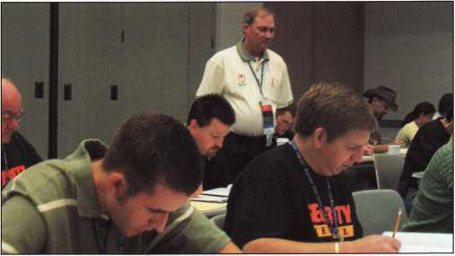

Gordon Racine, ALOA board member, proctors the PRP Exam while students concentrate on the exam.

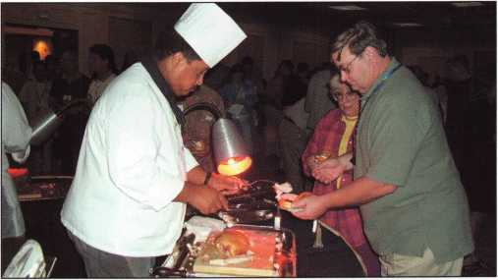

Attendees at the Kick-Off Party enjoy one of the eight meat carving stations at the party.

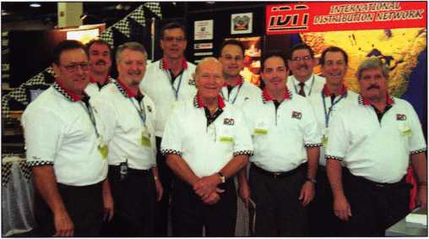

The staff of IDN, Inc in their booth on the show floor. IDN was the sponsor for this year's great Kick-Off Party.

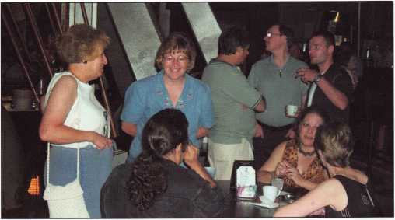

After the voyage through space in the Star Trek: The Experience attraction attendees enjoyed desserts and beverages in the Deep Space Nine Promenade.

September 2000

Keynotes



Jerome Andrews accepts the President's Award from John Greenan.

year’s,” stated Brooks. The first ever ALOA Live Auction was held immediately after the Kick-Off Party. It was a success as well. Approximately 160 people registered to bid for an array of products donated by various manufactures and distributors. All of the items were auctioned and the proceeds totaled a little over $31,000.

The proceeds raised by The Scholarship Foundation will benefit the Foundation’s quest to support those individuals that have the desire to further their education in the security industry. The Foundation provided 25 full package scholarships to ALOA 2000.

The overwhelming support of members and guests for the Scholarship Foundation was well received. The party set the tone for the opening of the Security Expo and the rest of the week’s activities.

The International members also made quite a splash at ALOA 2000. There were over 300 attendees representing 28 countries. The largest number of international members was from Japan with 90 attendees.

Speaking of Japan, Simplex Unican held a certification class for 32 members of the Japan Chapter attending the show. The class was originally scheduled to be taught in Japan, but the members chose to attend ALOA 2000!

The Security Expo opened it’s doors to a record number of attendees also. There was much to see, do, and of course, purchase on the show floor. From product demonstrations to new merchandise, it was like a shopping mall or new store on grand opening day. The last day of the Convention, ALOA gave away $1,000 each hour. For those of you who left early, your name was probably called, because it took us several attempts to give that cash away.

Congratulations to those $1,000 winners: Barb New-

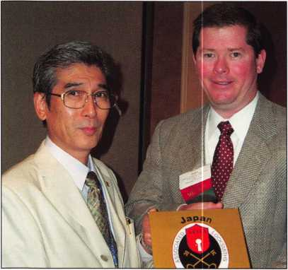

The Japan Chapter of ALOA presents John J. Greenan, CML, CPS, with an award making him an honary member of their chapter.

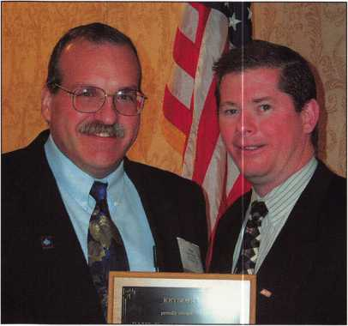

Paul F. Chandler, CRL accepts the Keynotes Author of the Year Award from ALOA President, John J. Greenan, CML, CPS.

From left Peter Fields, Jerry Hoffman, Al Hoffman and John J. Greenan at the Dinner Banquet. The Hoffman brothers were the recipients of this year's ALOA's Lifetime of Outstanding Achievement Award.

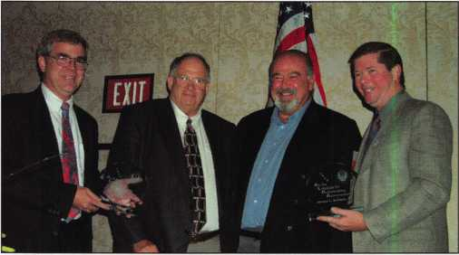

Keynotes

September 2000

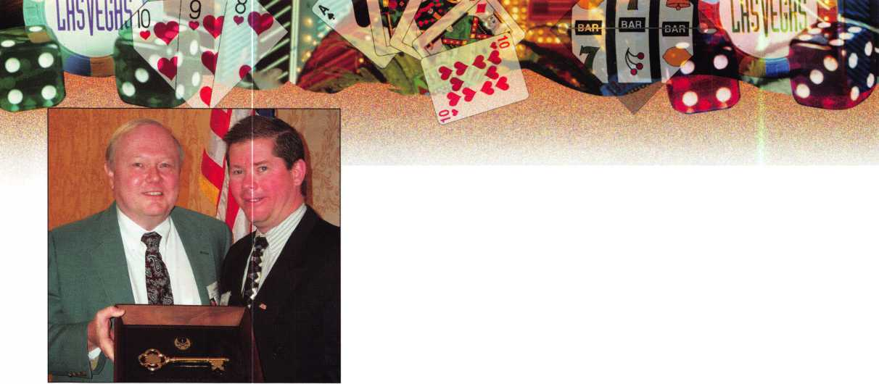

ton, Corvallis, Oregon; Anthony J. Ramuno, Youngstown, Ohio; James H. Strong, Devils Lake, North Dakota; and Jon Griswold, New Britain, Conneticut.

There were 20 additional companies and 59 more booths represented than last years show in Cincinnati. This was an 11% increase over 1999. Sales have already begun for ALOA 2001 in Baltimore. Start making plans now to attend!

The Dinner Banquet was a little different from anything done in the past. After everyone finished their dinner, the ALOA Lifetime of Outstanding Achievement Award was presented. The recipients of the award were brothers A1 and Jerry Hoffman, honored for their years of service to the industry.

At this point the entire crowd was escorted by a group of Klingons for a visit through the History of the Future Museum and a Voyage Through Space at Star Trek: The Experience attraction. While waiting to climb aboard the spaceship attendees were treated to numerous desserts and coffee. It was definitely an adventure to remember.

The annual membership meeting was held and the following awards were presented: Jerome V. Andrews, CML, received the President’s Award, Paul F. Chandler, CRL, received Keynotes Author of the Year, Bill Neff, CML received the ACE Award, and James H. Glazier, CML was recognized as a departing board member.

Wow! ALOA 2000 was definitely a show to remember. It was a week full of education, activities, experiences, and people from all over the world. And don’t forget the city — Las Vegas, “The Entertainment Capital of the World.”

Participation in the ALOA Convention is one of the benefits of our trade. At no other time will you have so much gathered under one roof. For those of you that missed this event plan now to attend ALOA 2001, July 16-22 in Baltimore, Maryland.

ALOA wishes to thank the sponsors and contributors who donated to ALOA 2000. Their support contributed greatly to the success of the Convention*m*

Class breaks were very popular as students enjoyed hot and cold beverages.

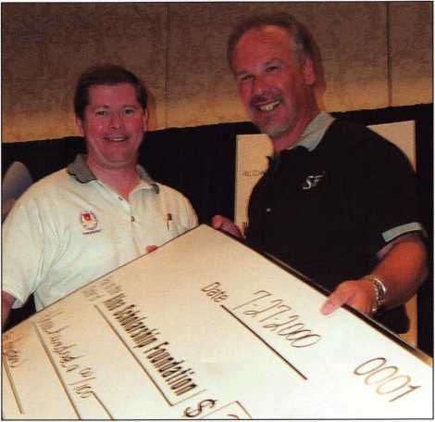

John J Greenan, CML, CPS, ALOA President and Steve Engel, member of the Scholarship Board present the $300 donation from Curtis Industries to the Scholarship Foundation.

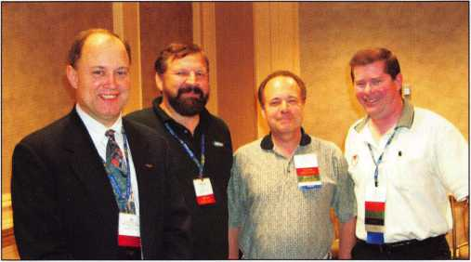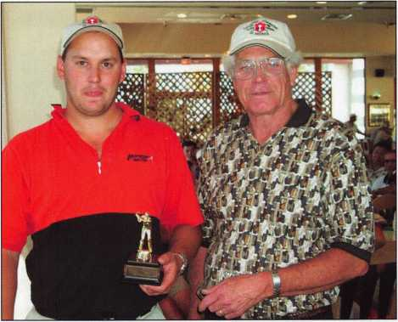

The President with members of the President's Club.

Jeff Beckman, the Men’s Low Net winner receives award from Reg Moxley, Co-chairman of the ALOA Open.

September 2000Keynotes

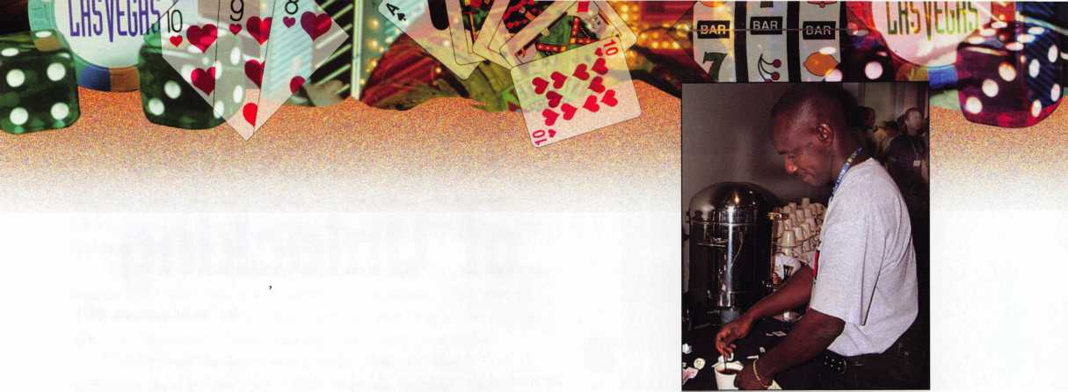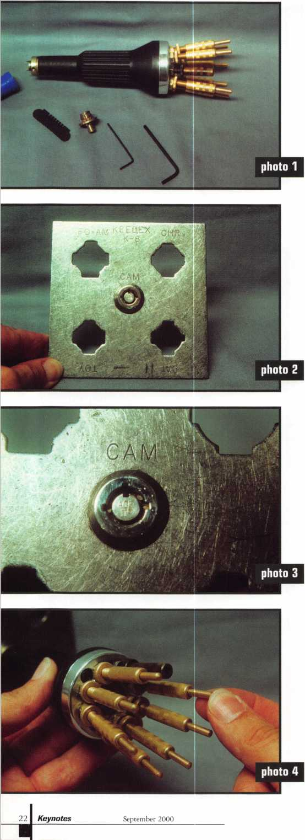

The Science of Unlocking

by Sal Dulcamaro, CML

It is often said that lock picking (or manipulation) is an art. There are many different types of locks with varied techniques and tools used in attempting to compromise them. In most cases, the skill of the manipulator is much more important than the specific tools used. When it comes to spring steel picks and turning tools (used for picking disc or pin tumbler locks, for example), you have something that can be recreated by nearly anyone. In a pinch, a couple of paper clips can be become pick and turning tool. A skilled lock manipulator with homemade tools will almost always outperform a beginner using the most expensive professionally manufactured tools. When it comes to tubular locks, skills are still very important, but the quality of the tool looms much larger.

When you pick a pin tumbler lock and the plug begins to rotate, the job is effectively accomplished. The plug will continue to rotate until the lock is actuated. It will rotate 360 degrees before re-locking. Tubular locks work differently. Even if you use traditional pin tumbler picking tools and are able to manipulate the tumblers whereas the lock will begin to turn, you will not go more than 45 degrees without it re-locking and forcing you to start from scratch to pick again. Tubular picks tend to be somewhat complex and are not likely to be easily made by the average locksmith. It is one type of tool that most of us will need to buy rather than make. The tubular pick is somewhat unique as a picking tool, because it effectively acts as a key after the picking process is completed. If done right, you should be able to lock and unlock the cylinder at will, as if you had the actual key. I have tried a number of tubular picks over the years, each with their good and bad points. The majority of installed tubular locks are of the standard 7 pin variety, but there are a number of interesting variations that have to be dealt with.

The Peterson PRO-1 Tubular Lock Pick

The Peterson PRO-1 is the newest and (in my opinion) best re-invention of the tubular pick. Now there are certain picking techniques that can’t be accomplished with the PRO-1, but I have found it to be exceptionally versatile and adaptable. While there is still a certain amount of “art” involved when using this picking tool, I believe that the PRO-1 makes picking tubular locks more of a science than an art. Although the skill and experience of the operator of this tool is still paramount, the PRO-1 provides the locksmith with more ammunition and fire power.

Photo 1 shows the Peterson PRO-1 with some of its accessories, outside its carrying case. It is larger and a bit different looking than a more typical tubular lock pick. The same basic tool is designed to work with standard .380 diameter 7 pin, 7 pin offset left and right,

8 pin, and the smaller .360 diameter 7 pin (like those used on Kryptonite bike locks) face opening tubular locks. Working with all those varieties is accomplished with (quickly and easily) removable key tips such as the included tip shown just to the left of the Allen wrenches in photo 1.

The inventor, Ken Persson, is not a locksmith. He is an engineer, with a knack for things small and precise, who decided to take on the challenge of the tubular lock in its many forms. He is currently exploring the possibilities of tools to challenge Medeco and some other high security locks. I look forward to seeing what he comes up with.

My first challenge was to hold the sample lock while I was using the tool. I went to my trusty Keedex K-8 impressioning plate, shown in photo 2, to mount the lock and then clamp the plate in a vise. That allowed me more control of the tool, instead of trying to hold both lock and tool. Keedex makes another version of the plate identified as part K-8B, with different lock type mounting holes.

Challenging the Ace II

Photo 3 shows a close-up view of the notorious Ace II tubular lock. Its heavy tension tumbler springs challenge the effectiveness of the more common tubular lock picks. I must confess that this particular lock was my greatest motivation at seeing what the PRO-1 could do. I was pleasantly surprised that it was more effective than I had otherwise hoped it might be.

In photo 4,1 am handling the brass probe end of one of the seven wire probes that are used to manipulate the tumblers. The long wire probe runs the length of the tool with the brass ends used to control the movement up and down. The key tip of the tool engages the keyway of the lock and allows you to apply rotational force when picking. It is a bit similar in concept to traditional pin tumbler lock picking. If you push inward on a wire probe while slightly applying torque, a probe that pushes back with the force of the tumbler spring cannot be bound and picked. The probes that resist inward movement (other than through tumbler spring pressure) are the tumblers that can be picked. My technique was not exactly the same as suggested in the instruction book for manipulating the tumblers. I figure that most locksmiths will do a bit of experimentation with a variety of techniques to see what works best for them.

While applying torque, I pushed the brass probe end inward. The wire probe moves the tumbler inward until it reaches the shear line, and makes a slight clicking sound. An internally threaded brass adjustment cap is turned clockwise, in photo 3, to keep the probe from being pushed back. When the tumbler is secured by the adjustment cap, it is necessary to find the next tumbler to bind. The procedure is repeated one tumbler at a time, until all seven tumblers are picked. Then the tool will allow rotation as if operated by a key. If not for the adjustment cap, slight rotation would cause the tumbler springs to re-engage the tumblers and re-lock the lock.

When it comes to the Ace II, this is where the PRO-1 excels compared to all the other tubular picks I’ve seen. Most standard tubular picks cannot withstand the tumbler spring pressure and just won’t even begin to pick the Ace II. There are a few picks that can lock the individual pick fingers or probes to resist the force of the tumbler springs. Where they come up a bit short is that they typically hold the probe from the side with a screw tip of sorts. Over time, the screw tries to lock into existing tracks cut into the side surface of the probe, and makes it difficult to precisely lock it where you want it. There will

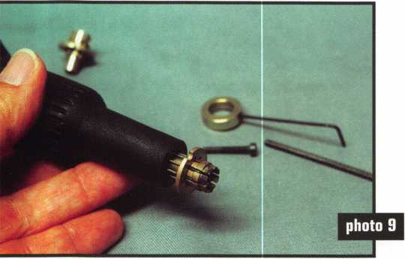

often be slippage, and the forced movement of the probes will sometimes cause the lock to re-lock during rotation. That will sometimes require re-picking the lock a number of times for complete rotation. The adjustment cap of the PRO-1 blocks any movement from the back, with virtually no chance of slippage. A very smart design.

Ideally, you want to make sure that the tip of the tool engages the tumblers while the tool is positioned perpendicular to the face of the lock. Slight tilting won’t necessarily stop the tool from working, but instead will make decoding the tool a bit awkward. While operating the tool like a key and turning sufficiently to unlock the lock, you may find yourself wiggling the tool a bit to find the tilt angle that allowed you to pick the lock. This problem is not peculiar to this particular tool, but happens with virtually any tubular pick if you hold the tool at a slight tilt, while picking. The better any tool is seated (perpendicular to the lock face) when the lock is ultimately picked, the less you will have to maneuver the tool during rotation.

If you think you may have tilted the tool a bit, you can rotate just slightly when it has been picked so the tumblers will be trapped in the unlocked position. Anywhere from 10 to 20 degrees rotation should be sufficient, as in photo 6. Then you can reset the tool.

There are a couple of ways to reset the tool to the specific picked pattern of the pins. One way might be to back off the brass adjustment caps, and then carefully re-insert the tool without rotating in either direction (to avoid re-locking). Making sure the tool is perfectly square with the face of the lock, you can push each of the probes inward until the movement is stopped by the pins locked in place (because the inner and outer pin chambers are out of alignment and the tumbler springs cannot affect the outer pins). As long as the inner and outer chambers are misaligned, pushing in on the outer tumblers will not re-lock the lock. Use some common sense, because if you use sufficient pushing force you can force the chambers back into alignment. Move the adjustment caps clockwise until you feel some resistance. Again, don’t overdo the amount of force. If you tighten the caps too far, the tip of the probe will start to push the tool outward so that it is no longer perpendicular to the lock face. That would cause a false reading when trying to decode, if making a key.

If you think that any tilting done was minimal, then you might try a slightly different technique. With the pins locked in place, I tried to make the tool perpendicular while trying to gently rotate the brass ends of the probe. If there was minimal or no resistance, it probably would mean that there is some space between the pin and the tip of the probe. If you can move the probe in and out a noticeable amount, you may want to tighten the adjustment cap a bit to remove most of the slack. If a probe will not rotate at all (when trying to rotate it), it generally means that the tip of the probe is in firm contact with the bound pin. You may want to back off the adjustment screw just a bit, and then test for any movement. If still extremely tight, you may need to back off even more. Once you think you have all the probe positions sufficiently fine tuned, you can try rotating the tool as if it were a key.

If you did things correctly, the tool should turn as smoothly as if it was a properly cut key. In that case, you should be able to decode the positions of the seven probes and get a fairly accurate reading. If it turns a bit rough or irregularly, you may have to jiggle the tool a bit to re-pick it back to an in between position where the tumblers can be re-bound. Then you can repeat the process just done, but be a bit more careful the next time. If you have it set where you want it and don’t want to accidentally move the adjustment caps, you can rotate the knurled locking nuts counterclockwise until they stop against the brass adjustment caps.

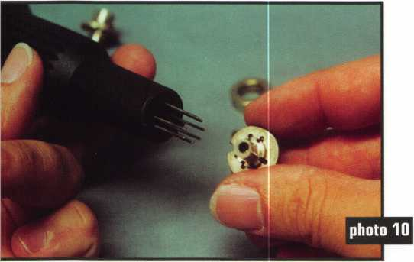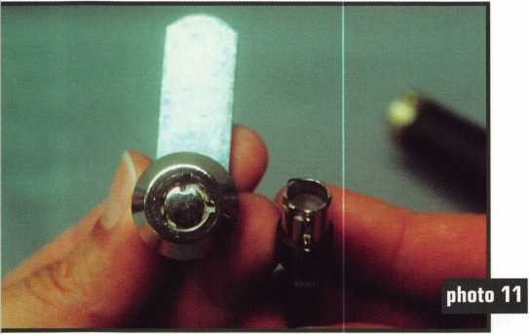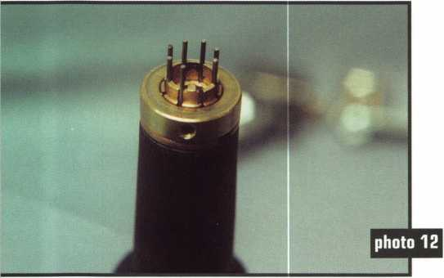

Keynotes

September 2000



Changing Key Tips

The part of the tool that engages the keyway of the tubular lock is called the “key tip”. This part is a removable and replaceable component. This feature makes the PRO-1 the most versatile of all the tubular lock picks. By changing tips, it is possible to make the tool capable of picking a differently configured tubular lock. For most of us who have other brand tubular picks, it generally means you need a completely different tool. For the PRO-1, it just means you need an accessory. It also means that it is expandable for use with other tubular lock types, without the expense of buying complete (specific use only) tools for those applications.

Converting the PRO-1 to other settings is amazingly simple and fast. First you loosen the set screw on the collar with the small Allen wrench, shown in photo 7. After removing the collar, loosen and remove the screw in the center of the currently used key tip, as in photo 8. Then pull out the key tip, as shown in photo 9, and ultimately remove it. You may want to pull the wire probes back into the body of the tool before you start removing the tip. If they stick too far out, you might accidentally bend them while removing and replacing key tips.

Photo 10 shows the tool with the key tip removed. The seven wire probes can be seen extending from the end of the tool. The under side of the key tip is also in view. It is “D” shaped to fit into a matching “D” shaped opening in the tool, in the center of the wire probes. When re-installing a key tip, the location of the “D” shapes must match and the wire probes must fit through the matching hole openings in the key tip. After seating the key tip properly, it must be reattached with the screw. Depending on the type of lock being picked, you will usually also reattach the collar. Different lock configurations will sometimes require relocating some of the wire probes. If working on an eight pin lock, you may have to get the spare wire probe that is stored in the tools plastic container.

Different Lock Configurations

Photo 11 shows a tubular lock with seven pins, but with the offset right configuration. I won’t go into the details of changing the specific key tip, as the procedure is essentially the same regardless of the particular key tip involved. There is one key tip that works with most standard diameter 8 pin, and both offset 7 pin (left or right) configurations. The primary difference between each of those three configurations is the placement of the wire probes.

Photo 12 shows the wire probes extended through the key tip. This is the key tip mentioned in the previous paragraph. I have positioned the set screw on the collar directly in line with the part of the tip that engages the entry slot of the tubular keyway. Seven of the eight hole openings are filled by a wire probe. Just to the right of the part that engages the key way slot is the empty space. If the pins of the lock had been offset in the opposite direction, the wire probe hole to the left would have been empty. An eight pin lock would require all eight probes.

Photo 13 shows a side view of the tool. I didn’t illustrate the process, but I had already relocated one of the wire probes to account for the offset pin pattern. The process is simple enough. I just unscrewed the adjustment cap all the way and completely pulled out the wire probe (that had to be repositioned). I then unscrewed the darker colored adjustment cap (that had no wire probe within it), and inserted the wire probe there. Afterward I refastened the adjustment cap, and the tool was ready. It is easily seen in the picture since there

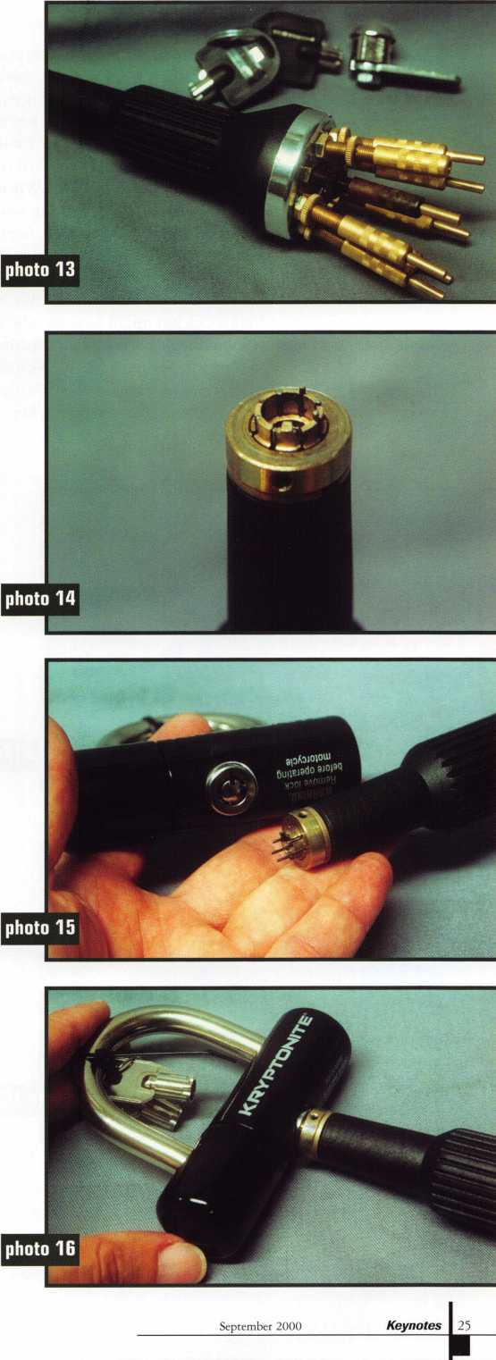

is a bright brass probe end sticking through a darker (almost antique brass) adjustment cap.

I used a similar picking procedure for this lock. This and most standard configuration (non Ace II) locks tend to have tumbler springs that are not excessively strong. So spring tension was not a major concern. When I pushed a probe inward, I didn’t encounter much counter force. The lock I was working with was a Kennedy tool box lock, and it seemed to have a rather thin face (where the pins stop against). When picking this lock, I could not fully press the tool into the lock (whereas the collar would stop against the outside face), because the deep key cut positions would be pressed inward too far by the tip of the tool. I had to pull the tool outward slightly to overcome the thin front wall. I don’t think this is common for most offset 7 pin locks, but might be a case where a special key tip might be more suitable. Photo 14 shows the positions of the wire probes that finally unlocked it. Because the tool had to be shifted and pulled outward to work, the probe positions would not be easily gaged for making a key.

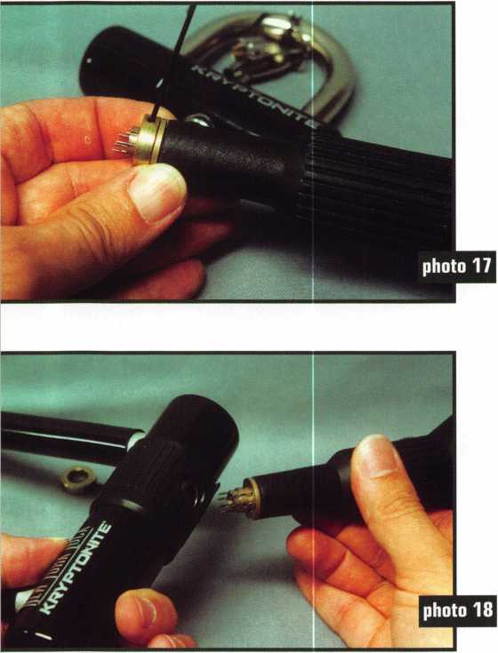

It Stopped Superman, but Not the PRO-1

Kryptonite made life difficult for Superman, and the tubular key type locks found on Kryptonite bicycle locks does similar things to most locksmiths with standard tubular lock picks. Kryptonite bike locks tend to use smaller diameter tubular keys. If you wish to duplicate Kryptonite keys, you had better get some of those smaller diameter tubular key blanks. Likewise, your standard diameter tubular lock pick will not enter the key way. The PRO-1 has an optional key tip that will work just fine in Kryptonite locks. A Kryptonite motorcycle disc brake lock is shown in photo 15, just behind the PRO-1 with the appropriate key tip already installed. Because the pin configuration is standard, you don’t need to switch any wire probes. Only the key tip must be changed to fit in the smaller opening. Photo 16 shows that the tool fits.

I had to remove the collar in photo 17, in order to work on a different Kryptonite lock. Photo 18 show the Kryptonite “New York Lock” that has a rotating plastic guard to cover the keyway (presumably to keep out dirt and debris while driving a bike). The guard interferes with the collar on the PRO-1, so I had to remove it. The same can be done when using other key tips, if necessary. You can see the tool in the same photo without the collar attached. There is a slightly different feel with the collar removed, but nothing to reduce the effectiveness of the tool. Superman might fear Kryptonite, but not the Peterson PRO-1.

I have not had the opportunity to try the PRO-1 on every conceivable variation of the tubular key type lock, but I am quite impressed with what it can do for the locksmith who is willing to learn to use it. In the instructional video, Ken Persson explains how to use the tool in a simple way, but most locksmiths have their own ways of doing things and will likely modify those methods along the way to learning the tool. Other noteworthy aspects of the tool are that it is impervious to oil, and has replacement parts available for virtually every component of the tool. A key tip for .340 diameter barrel type locks (used for some gum ball machines and other locks) will be available. A key tip is being developed for use with the Greenwald type locks.

If a new variation of the tubular lock comes on the scene, you will probably be able buy an accessory to deal with it rather than buying a whole new tool. If you are interested in the Peterson PRO-1 tubular lock pick, it is available from the following locksmith supply companies. Lockmasters Inc., 5085 Danville Rd., Nicholasville, KY 40356-9531, Phone: 606/885-6041. Sieveking Products Co., 3437 South Bend Road, Rockford, IL 61109, Phone: 815/874-4030. Brockhage International, 1137 Park Brook Ct, Milpitas, CA 95035, Phone: 888/547-8189, FAX 408/946-9731. Hawley Lock Supply, 2122 E. Van Buren St, Phoenix, AZ 85006, Phone: 800/398-2458.■

September 2000

Keynotes

VISA

^ ATM

DEBIT

CARD

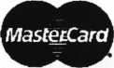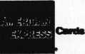

Diners Club International*

Accept Credit Cards  
and Increase Sales and Profits  
by 30% - 50%

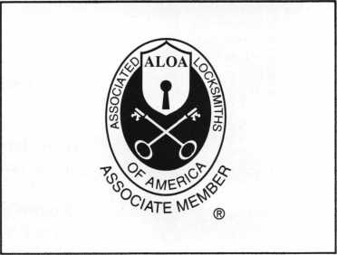

There are three reasons why people don’t accept credit cards:

Through Association Benefits **^** 1. Too expensive.

These Concerns Are Eliminated 2. The paperwork hassle.

3. Inability to qualify.

Here’s how it works:

* Simply swipe or enter the credit card #.
* Enter amount of sale. IVo Hassle - Easy Qualifying
* Approval within seconds.
* Funds wired electronically into your local checking account within 48 hours.

Curmi1iv4 Ne*s For to

....

*ss*&*rz*.: +

Because of your association membership, nearly 100% of all retail and home based applicants

will be approved even with past credit problems.

Currently Processing Merchants Please Read

Monthly Lease To Own Set-Up Options

Special Low Discount Rate and Transaction Fee: 1.59% + 20t

Plus Monthly Statement/Customer Service Fee: $10

Package A: $29.95 Terminal

Package B: $39.95 Terminal & Printer In One

Deluxe Package C: $49.95 Portable Terminal/Printer/Pin Pad  
Debit acess fee Ability to Accept Visa/MC “Check Cards”

SlO/mo. & ATM Cards at a FLAT 25*

Totally Eliminating the 1.59 % Rate  
(All lease terms 48 months • Monthly minimum $25)

] I authorize Universal’s sales office to print and deposit a check  
in the amount of $49 (normally $125) for my application fee which  
covers initial materials, application processing, equipment warranty,

shipping & handling, programming, installation and training.

* Fill out a check, tape here above mini form and then fax.

Fax Express Mini Form Now To **1** -**800**-**439-7773**

""'Per

!• rw'fcanrf-

.SPyoor,

[Changed

‘and act*™

*** wired

Sty

Company Name. Contact Name _

Address

City

State.

Zip.

Phone

Best Time

Signature

New Account Set-up Options (Cheek)

Package A j—j Package B I—I

Deluxe Package C I—I

Free Pin Pad Program For Currently Processing Merchants □

*A subsidiary of* Universal Savings Bank, FA.

Marketing Office *1-800-836-4295*

Universal Payment Processing Provides 24 Hour Live Customer Service.

September 2000

Keynotes



The Mercedes-Benz ignition has been a problem for a long time. Recently, during the ALOA convention, a new tool was shown by Lockmasters, a new tool has been invented that would solve the ignition servicing problem. The tool is designed to remove the collar from the switch of a 1 or 2-poke-hole ignition cylinder, allowing the inner works to be removed.

For those who service Mercedes, it is known that the ignition key must be turned a quarter turn in order to remove the key switch cylinder. This operation requires a key in working order and an ignition switch with its linkage also with full working integrity. In other words, from the key to the column all aspects must properly function to allow the depression of the detents for removal and servicing.

It is common sense and practice that there is little reason to work on the switch unless it is broken! The exception is when an entire lock change on all of the vehicle’s locks is to take place. The locksmith would simply rotate the switch key, hit the detents and pull the cylinder, popping in a new one in its place. The Sidewinder Ignition Drill is a solution for the locksmith when the cylinder or its linkage parts are not in working order. Those who work on the Mercedes ignition are aware that the rear “finger” found on the ignition cylinder will break and that the nylon linkage will also break not allowing the cylinder rotation needed for removal. The photographs and captions will help to pull you through the demonstration that was given at the ALOA show by Lockmasters’ Randy Mize. The manufacturer’s directions, in summation, are as follows.

* Disconnect the vehicle’s battery.
* Tighten the cutting blades of the tool.
* Lift out the plastic cap trim surrounding the key switch.
* Use a Dremel drill with a fiberglass­cutting wheel to remove raised dimples on the face of the black ignition cap until the surface is perfectly smooth.
* Lubricate the cutters with cutting oil and add some of the oil to the surface of the ignition switch.
* Insert the tool over the ignition face.
* Drill at a slow speed, with steady light pressure checking progress often and keeping things lubricated.
* Stop when you see that enough of the face cap has been removed to allow access to the hardened faceplate of the ignition cylinder.

Keynotes

September 2000

* With the aid of two small screwdrivers or one using the key way slot, remove the hardened faceplate from the housing.
* There is one or two spring retainers, resembling those made in the VW’s ignition switches, which need to be depressed in order to lift out the switch.
* Repair or replace the broken parts and fit the column switch with a new bezel shroud.

The following tips were the results of a short conversation with Randy while at the convention table. Two of the steps in the above procedures can be bypassed if you concede to a reduced life span for your tools cutting blades. The removal of the dimples will reduce the “chatter” of the blades jumping over the tips of the numerals. Since the tips of the numerals were all that the blades hit, the “chatter” only lasted for a quick moment. Randy ignored the dimple removal and simply set the drill into motion making quick work of the shroud cap removal. The second direction that he did not do was to use any cutting oil. His reasons were two. First, you are going to charge enough for the job that replacing worn out blades is not that big a deal.

Secondly, the oil as it heats up will begin to smoke. The smoke will fill the vehicle’s passenger compartment leaving, as you may suspect, a rather foul odor. I think that I would consider his reasons more than valid. I am not certain how the manufacturer would consider them with any warranties and the like.

This tool will be listed in Lockmas- ter’s new catalogue, which should be in your mailbox sooner than this article will find its way to press. The cost will be in the neighborhood of $400.00. A set of replacement cutters will set you back about $92.00. The cylinder removal tool wires will cost $28.00 each while the replacement bezels for the ignition switch will cost you $40.00 each. Remember that there are two different styles of bezels (shrouds). One is for the 1-poke-hole ignition switch and the other is for the 2-poke-hole switch. I know this tool will be very popular since Lockmasters convention show supplies were sold out early on the very first day of the show. I was assured that stock was more than ample in the warehouse in Nicholasville, Kentucky. You can order yours by giving them a call toll free at 1-800-654-0637 or you can visit their web site at [www.lockmasters.com](http://www.lockmasters.com).

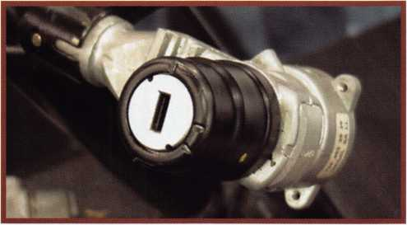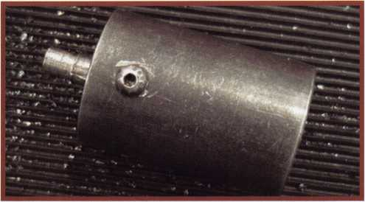

Mercedes-Benz ignition switch with the dominant black shroud {bezel).

The outer housing of the Sidewinder Drill with set screw.

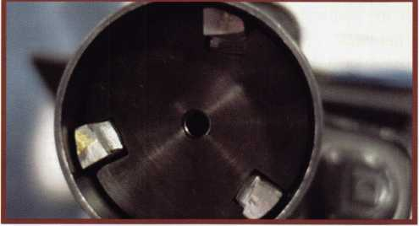

An end shot photograph showing the three carbide tipped blades that does the work on the hardened bezel.

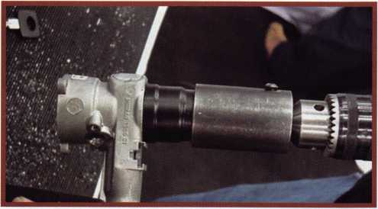

This shot is showing the drillis chuck with the sidewinder drill work­ing on the ignitioms bezel shroud.

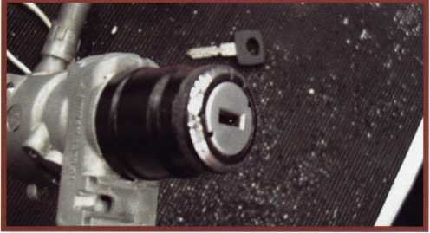

This is our first check of the progress that has been made. Notice that  
some of the bezel closest to the faceplate (showing in black) is still in  
place. This part is covering the hardened faceplate and will be removed  
at the end of the drilling process.

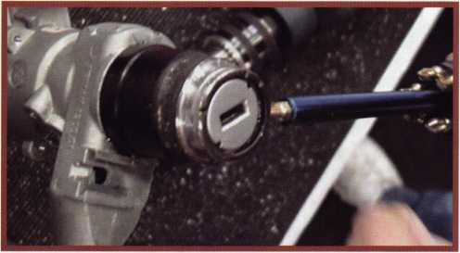

The blue and brass screwdriver is prying up the black collar ring that was formed from the drilling of the bezel shroud. Once this is lifted off the hardened faceplate will easily lift out of the way.

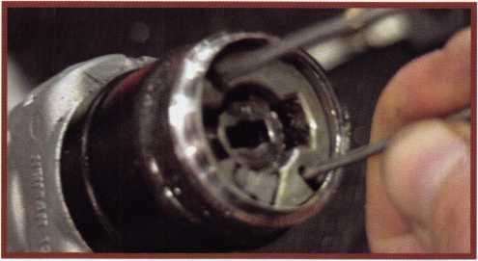

With the hardened faceplate now out of the way, the removal tool wires are inserted depressing the detents that will allow for cylinder removal.

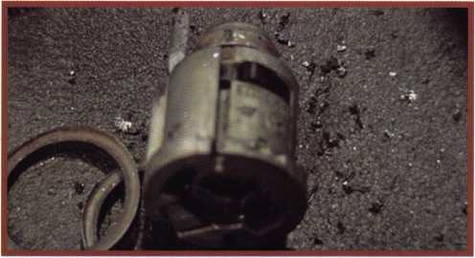

This photo shows two things other than the pieces that are lying about.  
First is the black detent that resembles that of a VWis detent. The sec-  
ond is the finger on the back of the cylinder, which is one of the possible  
breaking points for this style of switch.

September 2000 Keynotes



This year, the ALOA Scholarship Foundation  
awarded 25 full package scholarships to ALOA 2000 in

Las Vegas, Nevada. Of the 25 awarded 21 recipients accepted

and took advantage immediately by attending the classes offered  
in Las Vegas. Ask any one of those recipients and they’ll tell you  
how the scholarship was beneficial in gaining knowledge for the  
improvement and development in the field.

The Scholarship Foundation worked hard at ALOA 2000 and will continue to work throughout the year to raise funds for future awards.

Don’t get left out next year. ALOA 2001 in Baltimore will provide more educational and career opportunities for locksmiths and others in the security industry. Take the time and complete the scholarship application at the right.

You can take advantage of one of our associations most valued resources and learn more about the trade. Who knows, you could be one of the next recipients. The ALOA Scholarship Foundation is waiting to hear from you.

**THE NORTHEAST S TOP** EVENT!

A.L.0 A, A.C.E. certified instructors All new and innovative classes The industry's top manufacturers, distributors and manufacturers' representatives

|  |  |  |
| --- | --- | --- |
| Y TH | y ■ | N |
| < r\ |  | r |
| \ |  |  |
| i \  111 |  | , |

Keynotes

September 2000

-,j

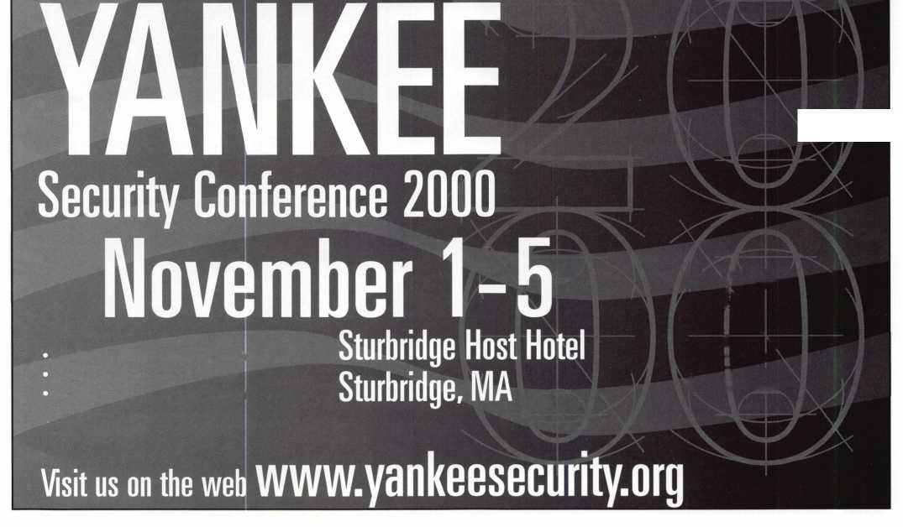

Scholarships are awarded to those individuals who demonstrate their financial need and their desire for more education in the locksmithing field. If you or someone you know fits the above criteria, please fill out the application on this page and send or fax to the ALOA Office at 3003 Live Oak St., Dallas, Texas 75204 by the due date on February 1, 2000. The fax number is (214) 827-1810. Don't forget to include your letter stating your reason for applying, your three letters of reference. No late or incomplete applications will be considered.

Please print or type

NAME

ALOA SCHOLARSHIP FOUNDATION, INC.  
ALOA/SAVTA SCHOLARSHIP APPLICATION  
3003 Live Oak Street; Dallas TX 75204; (214) 827-1701

PRPLEVEL

HOME ADDRESS.

CITY.

STATE.

ALOA/SAVTA #.

ZIP.

HOME PHONE.

DOB

PRESENT EMPLOYER.

WORK ADDRESS

POSITION

EDUCATIONAL LEVEL (YEARS] DEGREE, IF ANY_

_ WORK PHONE- FAX

CITY.

STATE.

ZIP

□ FULL TIME □ PART TIME TAKE HOME PAY $_

LENGTH OF TIME IN LOCKSMITHING .

OWNER/SUPERVISOR’S FULL NAME.

MEMBERSHIP IN TRADE ASSOCIATIONS (LIST BY NAME).  
MARITAL STATUS SPOUSE’S OCCUPATION _  
COMBINED HOUSEHOLD ADJUSTED GROSS INCOME $_

SPOUSE’S TAKE HOME PAY $_

NUMBER OF DEPENDENTS.

CLASSES DESIRED.

DATE OF CLASSES _

ORGANIZATION SPONSORING CLASSES: □ ALOA □ SAVTA □ OTHER (PLEASE NAME).

LOCATION

ALOA Scholarships are granted to selected individuals desirous of entering the locksmithing field or to selected individuals already in the locksmithing field who wish to improve their professional skills through education.

Applications for classes being taken locally must be received a minimum of 60 days prior to the date of the class, and will be reviewed as they are submitted. Scholarships for classes at the ALOA or SAVTA convention will be awarded each year at the ALOA Scholarship Foundation meeting preceding the convention and must be received by February 1 each year.

Please attach to this form a letter stating your reason for applying for a scholarship, what you plan to do with the knowledge you obtain and any other information you feel may be helpful to the scholarship board in making its decision. In addition, attach three let­ters of reference from individuals who have personal knowledge of your background and character. The letters should contain their names, addresses and phone numbers. It would be helpful if at least one of these references is an ALOA or SAVTA member.

All scholarship recipients will be required to provide a 3x5 inch photograph of themselves.

APPLICATION CHECK LIST

Only complete applications will be considered for scholarships. An application is considered incomplete unless ALL of the above requested information is received before the deadline: 60 days prior to the date of a class or February 1 for ALOA/SAVTA convention classes. Please send this application after checking off each of the below.

* I have filled in each blank on this form.
* I have written and enclosed a letter explaining my reason for applying.
* I have enclosed three letters of reference.
* I am submitting this in time to be received 60 days prior to the date of a class or by February 1 for ALOA/SAVTA convention classes.

CERTIFICATION OF APPLICANT:

I certify that the information contained herein, and all supplemental forms are complete and correct to the best of my knowledge. I further certify that if I am selected as a scholarship recipient I will use the knowledge gained for the improvement, development and advancement of the locksmithing profession.

Signature.

Date

/

/

September 2000

Keynotes

“If you want to study for the CPS test,

you need this book.

Without that book, I wouldn’t have my certification.”

-Dennis Johnson, CPS  
Aurora, Illinois

"Mike's new book is very  
consistent with the study  
information required to pass the  
SAVTA/ALOA CPS certification  
test I wouldn't have passed  
without it. *A tremendous  
resource for today  
and tomorrow..."*

-John T. Grist; CML, CPS

North Georgia Security

"The Safe Technicians Reference Manual by Mike Oehlert ranks among the best technical reference and learning aids you will find in the safe and vault industry. It contains page after page of essential information and easily understood illustrations. Besides answering most of the questions commonly asked by technicians new to the field, Mike has also included plenty of information experienced technicians will find useful."

-Ken Dunckel Pacifica, California

—►Over **600** Illustrations.-*—

320 **pages.** Only $135.

What are you waiting for?

To order, call 800-532-2562. Allow 3 weeks for delivery.

All major credit cards accepted; or make check payable to ALOA.

The Safe

Technicians  
Reference Manual

First Edition

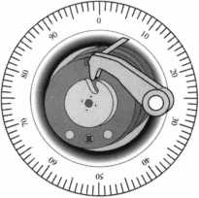

Keynotes

September 2000



Keep all of your employees informed and “in the loop” about your Company From manager to receptionist, field locksmith to bookkeeper. Every employee of your company is a potential sales representative and a member of your untapped sales force.

After working hours, people usually like to talk to friends and family about where they work and what they do at work. Work takes up a good part of their day. There is usually an interesting work-relat­ed story to tell each day. Perhaps enlightening conversation could be made describing a problem encoun­tered on a service call and the solu­tion. Conversation could surround new products introduced. Maybe discussion might include how a member of the staff solved a prob­lem using hardware in an innova­tive way. Its only natural that, after working hours, people talk to friends and acquaintances about what they do at work or/and what their company does.

Take advantage of your employee’s tendencies to talk about their organization by keeping everyone in the company aware of what is going on with new and existing products and services. When you do, EVERYONE in your company serves as an extra, subtle sales force. The more they tell others about the products and service their company provides, the better the bottom line may be for your company.

Don’t take for granted that every employee knows ALL the products that you sell and service, even in a small company. This may be especially true if your company provides diverse product lines or services, or if there are different departments working in specific areas. Reinforce the fact that your organization has many talented

people providing diverse products and services, some of which only involve a particular group of indi­vidual employees (for example, safe work, safe deposit locks, or auto­motive work). Report when you launch new products or services or when you have secured a contract for a large job. Publicize news about a new contract with existing or new companies.

Corporate announcements of new products, new services and other advances should be made on a regular basis. The more product and service knowledge everyone in the company has, the more they can pass on. And that just might turn into extra sales.

How to get the word out? Put it in a memo, send it in an e-mail or create a poster to be hung on the wall. There are many different (and sometimes imaginative ways) to disseminate product/service infor­mation to all employees of the company. For instances, schedule staff or department meetings regu­larly devoting time for discussion about the latest and greatest hap­penings. These meetings don’t have to last long. Perhaps a few minutes at the beginning or end of a week could be devoted for brief announcements. You can hang a small sign or poster on a bulletin board describing a major company accomplishment or a letter or appreciation from a customer. Some manufacturers can provide you with a small poster describing a new product also.

Interoffice memos are usually good vehicles to disseminate good news. These can be either paper or e-ail memos. If you don’t think your staff will read the memos, make reading them worthwhile.

Put in a specific message in the body of your memos that will give employees an incentive to read

them. The message can include a simple contest that encourages them to fill out an entry form in order to be entered into a drawing for a prize.

And you don’t have to offer a prize or run a contest in every memo. Just do it often enough and randomly enough so your everyone in your organization remains inter­ested, in the “loop or/and eager to read your memo updates.

We’ve discussed memos, meet­ings, e-mail and posters, but there is one company communique that always gets noticed. It’s the pay- check (unless you provide direct deposit)). Everyone opens this enve­lope. This envelope may be a great place to put important company announcements.

Unless your company has secrets that must be kept, you should keep every employee in the know about ALL products and ser­vices their company provides. In this case, well-informed lips may just boost sales.*



September 2000

Keynotes

by Tim McMullen

ALOA Convention a Winner for  
Legislative Action Network!

On site information, a thank you reception, sharing ideas with other states and popcorn highlighted this year's legislative convention activities. The Legislative Booth, gave members a chance to find out what was happening at their state capitol that could effect their businesses. Even better, we had over sixteen new people sign up for the Legislative Action Network! We had a silent auction at the booth, and thanks to the generous donations by HPC, Inc. and The National Locksmith, we raised over $1375! Special thanks to our win­ners: Dana L. Barnum, CML; Corey J. Friedman; and R.J. Stowers for their wonderful contribution to the Legislative Fund. And of course, there were traditional hats and keychains given out, plus the ever present aromatic popcorn given away this year by the smiling face of convention regular, Niki Engel (daughter of Steve Engel, CML, CPP).

The Legislative Action Network Reception held Friday night, gave everyone an opportunity to relax a bit after being on the show floor and in meetings all day! It was also a way for ALOA to say, “THANK YOU” to all the Network members for going above and beyond the call of duty, such as traveling 300 miles to the statehouse and giving testimony before a Senate committee. A special presentation was made to the Legislative Action Network's Member of the Year, Thomas G. Gillingham, Jr, CPL (who unfortunately could not attend this year's convention), who worked long and hard on the Tennessee Safe Deposit Law which was defeated. A “passing of the hat” garnered over $1200 in donations.

Mark Blum, CML, CPS himself donated $1000!

Once again we held the State of the States Roundtable, which was another great meeting for the exchange of information and ideas. There were over 20 people in attendance, including multiple representatives from the Alabama Locksmith Association; California Locksmith Association; Fox Valley Chapter; Grand Canyon Chapter; Greater Philadelphia Locksmith Association; Indianhead Chapter; Institutional Locksmith Association; Japan Chapter; Keystone Chapter; Korea Chapter; LA Chapter; Louisiana- Mississippi Locksmith Association; Maryland Locksmith Association/Chesapeake Chapter; Master Locksmith Association of New Jersey; Missouri-Kansas Locksmith Association; National Locksmith Association of Canada;

New Mexico Locksmith Association; Nutmeg Chapter;

Trustee Dallas C. Brooks and President John J. Greenan, CML/CPS. Some of the highlights included:

**34 | KeynotesSeptember 2000**

* Alabama reported that they were trying to get locksmiths added to the security law.
* New Jersey was going through regulation process on their licensing law.
* Missouri-Kansas invited everyone to MINK September 28-2-, 2000.
* Connecticut is going to reintroduce its licensing bill in 2001.
* Grand Canyon Chapter is having its 15 year anniversary on November 18, 2000.
* California Locksmith Association will have its 45 year anniversary this year.
* Institutional Locksmith Association will be having its annual conference at Ilco Unican October 2-3, 2000.

They are looking at raising their membership to over 200.

The biggest discussion was brought to light by the Korean Chapter. They would like more to say on who can become a member of ALOA. By the time they get the magazine, the person has qualified under the 90 day probation period. They suggested that there be a monthly fax from ALOA sent to the closest chapter so that people can respond to a candidate. It was also suggested to post candidates names on the website.

The hour-and-a-half session proved to be both a networking opportunity and highly informative. The meeting was also a prime opportunity to let everyone know what was going on in their states with various pieces of legislation or current laws.

At the Legislative Action Network Council (donors of over $100), we discussed the recent influx of Positive ID Policy bills, the rights to master key systems, some kind of self-regulation of the industry, and a low-voltage license.

There was discussion about ALOA being proactive on licensing next year in Connecticut and Utah, and also the suggestion that we be proactive in Louisiana, and turn back the changes to the original bill.

It was another great convention for ALOA's Government Affairs Department, and we look forward to seeing you next year in Baltimore, Maryland!



LEGISLATIVE UPDATE

All bills that saw movement between 06/15/00 and 08/15/00

NORTH CAROLINA H1177

SUMMARY:

Establishes Locksmith Licensing Act; makes it Class 3 misde­meanor to perform locksmith services or possess locksmith tools, safe-opening tools, or code books without license; provides for licensing fees; provides for mem­bership of Locksmith Licensing Board; provides powers and duties of Board; requires that before opening locked door to any vehicle or residential or commercial property, licensee must make reasonable effort to verify that customer is authorized to gain access.

STATUS:

07/13/2000 In HOUSE. Indefinitely postponed.

NEW YORK S2530

SUMMARY:

Makes it a class A misdemeanor to knowingly possess equipment used to duplicate keys under circumstances evidencing intent to use such devices to unlawfully enter or operate a vehicle.

STATUS:

06/15/2000 From ASSEMBLY Committee on ECONOMIC DEVELOPMENT, JOB CREATION, COMMERCE AND INDUSTRY.

06/15/2000 Passed ASSEMBLY.

It's True

Marray has developed the first  
screwless door loop.

Aluminum ma­terial means true anodizing.

No off color powder coat­ing or painting

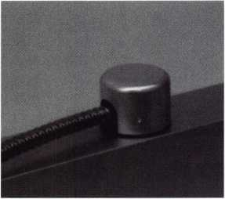

Standard 18” length. Can be ordered in cus­tom lengths

Plastic base stops shorts and pro­tects wires

Screwless base and cap means you drill two 1/2 inch  
diameter holes, pop the base into the hole, wire your  
system and snap on your covers. Simple as 1, 2, 3.

**Here’s the best part We are giving away a**

FREE SAMPLE TO THE FIRST **1 (X)** CALLERS WHO MEN-  
TION THIS ADD. A $14.40 WHOLESALE PRICE VALUE.

CALL TODAY, IT’S FREE!!

1-800-500-1449

Marray *enterprises, inc.*

At Marray, we’re not just modifiers, we’re Master Hardware Modifiers™  
1128 Walsh Ave., Santa Clara, CA 95050. [www.marray.com](http://www.marray.com)

September 2000

Keynotes

**Keynotes**

Classified



J Classified Advertising Policy

Classified advertising space is provided free of charge to ALOA members, and for a fee of $.60 per word, $15 minimum for non-members. Classified ads may be used to advertise used merchandise and overstocked items for sale, “wanted to buy” items, business opportunities, employment opportunities/positions wanted and the like. Members or non-members wishing to advertise services or new merchandise for sale may purchase a “Commercial Classified Ad,” for a fee of $1.30 per word, with a minimum of $40. Each ad will run for two issues. For blind boxes there is a $5 charge to members and non-members. All ads must be submitted in writing to the ALOA office by the fifteenth of the month, two months prior to issue date. Send to Keynotes Classifieds, 3003 Live Oak St, Dallas TX 75204-6186. ALOA reserves the right to refuse any classified advertisement that it deems inappropriate according to the stated purpose of the classified advertising section.

■ EMPLOYMENT

Commercial Locksmith Wanted

9/F/3: Established in 1900 Atlanta’s oldest locksmith business needs experienced Locksmiths and electronic security technicians to support rapid growth. Great pay, paid insurance, retirement plan, paid vacation and holidays. Need to be a highly motivated team player, bondable and have a clean driving record. Please fax resume to: Calvin Pinson

Downs Safe & Lock Co., Inc.

1846 Cheshire Bridge Road Atlanta, GA 30324 (404) 873-2515 (404) 873-4581 fax

Experienced Security Professional Wanted

9/F/3: Maryland security service company seeking an experienced security professional to join our team. Our service areas include high security locks, safes, access control, CCTV and general locksmithing. We service government and commercial clients throughout Maryland and the metro­politan District of Columbia area.

We offer a competitive salary, excellent health, dental, life, short and long-term disability insurance.

We also offer paid holidays, vacation, retirement plan with company contribution, bonus programs, company vehicle, uniforms and a great work environment. A signing bonus is available.

Successful applicant will be subject to a security investigation and must meet eligibility requirements for access to classified information and have an acceptable driving record. Dave Harris, CML Chesapeake Security Service Co. (301)855-9131 (410) 535-1372 fax clssc@ Chesapeake, net

**36** | **KeynotesSeptember 2000**

Experienced Service & Shop Technicians Needed

9/F/3: Due to continued growth, we are looking for outside and inside service technicians. Our company has been in business since 1880 and is located in the beautiful Pacific Northwest. Argens Inc. is a multi­dimensional company. We target commercial and industrial accounts of all sizes. Our company specializes in general locksmithing, electronic security (card access & CCTV), door servicing and gate systems. We are an employee driven company with excellent pay, benefits, sales incentives and can offer advancement as our growth continues. Send resume to:

Jim King Argens Inc.

84 S Main Street Seattle, WA 98104 (206) 623-2662 (206) 622-5056 fax argens @w-link. net

Experienced Locksmith Required

9/F/3: Experienced locksmith required immediately for national locksmith company. Minimum 2 1/2 years experience. Electronic and safe background, (Defiant) asset for candidate. Excellent salary package and full benefits. Apply to:

John Hanning Chubb Lock & Safe #8 5708 1st Street SE Calgary Alberta Canada (403) 255-2222 (403) 258-1702 fax

Make $ $ $

9/F/3: Relocate!! Company in “Houston, Texas is seeking a serious experienced locksmith with tools and vehicle. Great pay, bonuses, benefits and paid vacation.

Contact Fred:

(281) 497-5555 (281) 830-9441 (713) 266-4350 fax

Electronic Locksmith Wanted

9/F/3: Locksmith experienced in installing and servicing access control systems needed. Need expertise in installing electric strikes, maglocks, keypads and card readers. Send resume to:

Electronic Locksmith PO Box 1056 Birmingham, AL 35201

Locksmith Position Available

9/F/3: Full and part time positions available with busy locksmith shop in Ventura County California. Desired 2-3 years experience with automotive, commercial, residential service calls. Need flexible inside/outside person. Commissions paid in excess for after hours service calls. Newer air conditioned trucks provided. Would prefer applicant with own tools.

Please inquire a.s.a.p. [ExitatMainSt@aol.com](mailto:ExitatMainSt@aol.com)

(805) 701-3444 (805) 794-4458

Experienced Help Wanted

7/F/3: Locksmith division of one of the top security/alarm companies in Illinois (Chicago area) is searching for a qualified technician. Must be experienced with most aspects of physical security, electrical locks and master key systems. Safe service and repair knowledge would be helpful. If this sounds interesting and you think you have what it takes to grow with us, call our personnel department or send a resume to:

Security Master, Inc.

Personnel Director Locksmith Position 1100 Church Rd Aurora, IL 60505 (630)844-6330 (630) 844-6326 fax [hr@adsalarm.com](mailto:hr@adsalarm.com)

Experienced Locksmiths Wanted

9/F/3: Wanted!! Austin, Texas and San Francisco, Calif., experienced locksmiths in auto, commercial and residential. America’s fastest growing Mobile Locksmith. Best salary and benefits.

David

(512) 657-6404

Locksmiths Needed

7/F/3: Mid sized company in Aurora, Colorado (just outside Denver) seeking two individuals for outside field work. Our company offers a family atmosphere, paid vacations, paid holidays, 401K, company provided vehicle, gas and tools (except hand tools). We are looking for individuals who are courteous, professional and willing to learn as the market changes. We cater mainly to the commercial customer with very little automotive. Access control and safe knowledge required, certification is not. We will consider relocation assistance. Call: **Sheila ACSC**

(303) 745-5500

Experienced Locksmith Needed

7/F/3: Experienced locksmith needed for the San Diego area. Immediate position available for an experienced locksmith. Our company has been in business for over 25 years and is located in beautiful, sunny California. We are an employee driven company that offers competitive salary, paid vacation, holidays and sells incentives. Call, fax or write:

La Jolla Lock & Safe PO Box 401 La Jolla, CA 92038 (858) 459-1225 (858) 456-9004 fax

■ BUSINESSES FOR SALE

Locksmith Business For Sale

9/F/2: Locksmith business for sale in northwest Alabama. Established in 1973. Tri-state service area of 250,000 plus population. Industrial, commercial and banking accounts. Mobile service, large walk-in traffic. Gross $125,000. Good growth potential. Terms negotiable. Mild Alabama winters. TVA Lakes on Tennessee River for boating and fishing. Lake shore homes. **Security Lock & Key PO Box 2191 Florence, AL 35630 (256) 764-3349 (256) 766-7083 fax**

Mobile Locksmith Business For Sale

9/F/2: Established in 1976, family run and operated and serving the Marion/ Polk County area in the beautiful Willamette Valley. Currently being run as a one man business with lots of potential to be a shop/mobile business as it has in the past. Owner is anxious to sell, due to change of careers and relocation.

Includes a 1993 Dodge Ram 350 van with custom interior, Redi-line converter, Pentium laptop computer, HPC locksmith software, an outstanding selection of power, hand and locksmith specific tools, inventory, key blanks, etc. Also includes company name, customer list, customer records,

800 number, custom phone number, web site, great reputation, etc. Currently grossing $30,000 part time, but a smart aggressive businessman could easily double that in no time. Asking $35,000 or best offer. Owner will partially finance.

PO Box 5698 Salem, OR 97304-0698 (503) 364-5397 actionlock @home. com

Locksmith Business For Sale

9/F/2: Well established lock and safe business for sale in the mid-west.

Includes all inventory and equipment, two fully equipped mobile service trucks, and shop located on corner of very busy intersection. Gross sales for 1998-$ 190,000; 1999-$240,000.

Asking for $230,000 including property, which appraised at $95,000. Current owner can assist with financing. Inquiries may be made by calling:

(815) 654-0882

Business For Sale

9/F/2: Well established lock shop in Northern California tourist town in the Redwoods. Close to rivers, lagoons, mountains, fishing and hunting.

Twenty years at the present location and still growing. Commercial and residential accounts, safes sales and opening, roadside contracts and two fully stocked vans. Owner wants to semi-retire, but will stay on for smooth transition. Grossing $170,000. Asking $130,000 plus $21,000 for a new fully stocked van plus inventory. Send inquiries to:

PO Box 961 Willits, CA 95490

Locksmith Service for Sale

7/F/2: Tampa, Florida’s foremost mobile locksmith service for sale. Established in 1982. Sale includes merchandise, assets, 1996 service van, customer list and telephone number. Richard Formica, CML **(813) 985-2028**

Locksmith Business For Sale

7/F/2: Established in 1974, locksmith business with three fully equipped service vehicles. Storefront with showroom. Centrally located in Connecticut. Many established accounts, commercial and residential. Medeco DBK dealer, Peaks and an Abloy dealer for over 20 years. All equipment, shop and office, including up to date codes on computer. Owner ready to retire. Serious inquiries only.

Reply to:

(203) 237-3762

***Keynotes \*** 37

September 2000

Associate members of the Associated Locksmiths of America (ALOA) manufacture or distribute materials or equipment, or provide services, for the security industry. Many have donated money, services and equipment to ALOA in addition to their annual dues. Their support of ALOA projects enhances overall membership benefits and we encourage our members to patronize these firms. If you know of a potential

|  |  |  |  |
| --- | --- | --- | --- |
| MANUFACTURERS | American Security Products (AMSEC)  11925 Pacific Ave.  Fontana, CA 92337-6963 (800) 423-1881; FAX (909)685-9685  (33 0 | candidate for associate membership, please contact the ALOA Membership staff at (800) 532-ALOA. Associate member dues are $500 per year and entitle the payor to use the ALOA logo, and receive selected discounts | |
| A & B Safe Corp.  171 S. Del sea Dr.  Glassboro, NJ 08028 (800) 253-1267; FAX (856) 863-1208  0 (0 0 0 | Arrow Lock Company  10300 Foster Avenue  Brooklyn, NY 11236 (718) 257-4700; FAX (718) 649-9097  0 0 0 0 | on ALOA products and services.  Legend  ® Alarms: Personal, vehicle, electronic, fire, burglar, and exit © Bank security equipment ® Automotive: Lockout equipment, key chains/rings  © Builders Hardware: Door closers, furniture/decorative hardware, viewers, emergency exit devices | |
| ASSA Inc.  10300 Foster Ave.  Brooklyn, NY 11236 (800) 235-7482; FAX (718) 257-2772  © | Auto Security Products (A. S. P.)  P.O. Box 10  Redmond, WA 98073-0010 (425) 556-1900; FAX (425) 558-1205  0 (0) |
| Abus Lock Company  3555 Holly Lane North  Plymouth, MN 55447-0507 (800) 352-2287; FAX (612) 509-9939  © | Buddy Products  1350 S. Leavitt Street  Chicago, IL 60608  (800) 886-8688; FAX (312) 733-8536  0 | © Business/Technical & Educational:  Books, reference guides, publications, computer software  © CCTV/Photo Imaging: Cameras, monitors, photo ID equipment, cables § Electric/Electronic Security: Card | |
| Adams Rite Manufacturing Co.  P.O. Box 1301  LaPuente, CA 91749-1301 (562)699-0511; FAX (562) 699-5094  0 0 0 0 | BWD Automotive  900 Ravenwood Dr.  Selma, AL 36701  (334) 874-9001; FAX (334) 874-6011  0 (0 | access control and readers, surveil­lance, electric/magnetic locks and strikes, keypads  ® Lock Devices: Auto locks, cylinders, emergency exit/entrance control, locks (various types), strikes ® Tools & Supplies: Key blanks, cutters, picks, rings/hooks, custom van/truck supplies  © Safes/Vaults ® Other | |
| Adesco Safe Manufacturing Co.  web: [www.adesco.com](http://www.adesco.com) email: [sales@adesco.com](mailto:sales@adesco.com) (800) 821 -6803; FAX (562) 408-6427  0 | Chicago Lock Company  10100 88th Ave.  Pleasant Prairie, Wl 53158-0069 (800) 445-3204; FAX (414) 947-7178  © |
| Adrian Steel Company  web: [www.adriansteel.com](http://www.adriansteel.com)  Adrian, Ml 49221  (800) 677-2726; FAX (517) 265-5834  ® | Corbin Russwin Architectural Hardware  P.O. Box 25288  Charlotte, NC 28229 (800) 543-3658; FAX (800) 447-6714  (0) (0 (0 (0 | Don-Jo Manufacturing, Inc.  P.O. Box 929  Sterling, MA 01564 (508)422-3377; FAX (508) 422-3467  01 (0 |  |
| Alarm Lock Systems, Inc.  345 Bayview Ave.  Amilyville, NY 11701 (800) ALA-LOCK; (516) 789-3383  © | Curtis Industries  6140 Parkland Blvd, Ste. 300  Mayfield Heights, OH 44124-4103 (800) 555-5397  0) (0 | Door Controls International  2362 Bishop Circle East  Dexter, Ml 48130  (800)742-3634; FAX (800) 742-0410  0 0 0 0 |  |
| Aiphone Intercom Systems  1700-130th Avenue, NE  Bellevue, WA 98005 (425) 455-0510; FAX (425) 455-0071  0 0 0 | DETEX  302 Detex Dr.  New Braunfels, TX 78130 (800) 729-3839; FAX (830) 620-6711  0 (0) (0 (0) | ESP Lock Products, Inc.  375 Harvard Street  Leominster, MA 01453 (978) 537-6121; FAX (978) 534-9109  © ® |  |
| American Lock Co.  3400 West Exchange Road  Crete, IL 60417-2099 (708) 534-2000; FAX (708) 534-0531  ® ® | DSC Group of Companies  3301 Langstaff Road  Concord, Ontario, Canada (905) 760-3000 ext. 2200; FAX (905) 760-3040  0 0 (0 (0 (0 | Folger Adam Security, Inc.  16300 W. 103rd Street  Lemont, IL 60439  (630) 739-3900; FAX (630) 739-6138  ® © |  |
|  |  |  |  |

Associate

Members

■0

Keynotes

September 2000

|  |  |  |
| --- | --- | --- |
| Fort Lock Corp.  3000 N. River Rd.  River Grove, IL 60171 (708) 456-1100; FAX (708) 456-9476 | Knaack Manufacturing Co.  420 E. Terra Cotta Ave.  Crystal Lake, IL 60014 (800) 456-7865; FAX (815) 459-9097 | National Cabinet Lock  200 Old Mill Road, P. O. Box 200  Mauldin, SC 29662 (864) 297-6655; FAX (864) 297-9987 |
| • ••••• | • | • |
| Grobet File Co. of America  750 Washington Ave.  Carlstadt, NJ 07072 (800) 962-7242; FAX (800) 243-2432 | LAB Security  700 Emmett St.  Bristol, CT 06010  (800) 243-8242; FAX (203) 583-7838 | Newman Tanks  805 N Buckman St.  Shepardsville, KY 40165 (800) 826-5792; FAX (800) 777-8229 |
| • | * | • • |
| H.E.S., Inc.  2040 W. Quail Ave.  Phoenix, AZ 85027 (602) 582-4626; FAX (602) 582-4641 | LCN Closers (Division of Ingersol)  121 W. Railroad Ave.  Princeton, IL 61356  (815) 875-3311; FAX (815) 875-3222 | ROFU International Corp.  2004-B 48th Ave.; Court E  Tacoma, WA 98424 (800) 255-7638; FAX (253) 922-1728 |
| • • • | • | • • • |
| HPC, Inc.  3999 N. 25th Avenue  Schiller Park, IL 60176 (847) 671 -6280; FAX (847) 671 -6343 | La Gard, Inc.  3330 Kashiwa Street  Torrance, CA 90505 (310) 325-5670; FAX (310) 325-5615 | Rutherford Controls Inc.  2697 International Pkwy, Bid 5 #100  Virginia Beach, VA 23452 (757) 427-1230; FAX (757) 427-9549 |
| • • • | • • • | • |
| HID Corporation  9292 Jeronimo Road  Irvine, CA 92618  (949) 568-1600; FAX (949) 568-1680 | Lucky Line Products  7890 Dunbrook Rd.  San Diego, CA 92126 (619) 549-6699; FAX (619) 549-0949 | STRATTEC Security Corp.  3333 W. Good Hope Rd.  Milwaukee, Wl 53209 (414) 247-3333; FAX (414) 247-3329 |
| • • | • | • • • |
| High Tech Tools  1400S.W. 1 Street  Miami, FL 33135  (305) 649-7014; FAX (305) 541-0074 | M.A.G. Engineering & Mfg. Inc.  15261 Transistor Lane  Huntington Beach, CA 92649 (714) 891-5100; FAX (714) 892-6845 | Sargent & Green leaf, Inc.  P.O. Box 930  Nicholasville, KY 40340-0930 (606) 885-9411; FAX (606) 887-2057 |
| • • | • • • | • • • • |
| Hongtai Lock Co. Ltd.  Jidong, Xiaolan Road, Xiolan Zhongshan/Guangdong, China 528415 (86) 137-238-1414; FAX (86) 208-793-3856 | MARKS USA  5300 New Horizons Blvd.  Amilyville, NY 11701 (516) 225-5400; FAX (516) 225-6136 | Schlage Lock Co.  1915 Jamboree Suite 165  Colorado Springs, CO 80920 (800) 847-1864; FAX (800) 452-0663 |
| • • • • | • | • • |
| llco Unican  400 Jeffreys Road  Rocky Mount, NC 27804 (252) 446-3321; FAX (252) 446-4702 | MARRAY ENTERPRISES  1128 Walsh Avenue  Santa Clara, CA 95050 (408) 970-0213; FAX (408) 970-8767 | Schwab Corporation  110 Professional Court  Lafayette, IN 47905 (765) 447-9470; FAX (765) 447-8278 |
| • •••••• | • • • | • |
| In Out Systems, Inc.  3650-B Matte Boulevard  Brossard, Quebec J4Y-2Z2, Canada (450) 444-5949; FAX (450) 444-4856 | MUL-T-LOCK USA, Inc.  300-1 Route 17 South Suite A  Lodi, NJ 07644  (800) 562-3511; FAX (973) 778-4007 | Securitron Magnalock Corp.  550 Vista Blvd.  Sparks, NV 89434  (800) 624-5625; FAX (702) 355-5636 |
| • • | • • • | • • |
| Intellikey  551 S. Apolo Boulevard, Suite 204  Melbourne, Florida 32901 (800) 226-0703; FAX (407) 724-0811 | Master Lock Company  2600 North 32nd Street  Milwaukee, Wl 53211 (414) 444-2800; FAX (414) 449-3114 | Security Door Controls  3580 Willow Lane  Westlake Village, CA 91361 (805) 494-0622; FAX (800) 959-4732 |
|  | e e | • |
| KABA High Security Locks  P.O. Box 490  Southington, CT 06489 (860) 621 -3601; FAX (860) 621 -9727 | Medeco Security Locks  P.O. Box 3075  Salem, VA 24153  (540)380-5000; FAX (540) 380-5010 | Security Solutions  1640 W. Hwy. 152  Mustang, OK 73064 (405) 376-1600; FAX (405) 376-6870 |
| • | • • • | • • • |
| KEY-BAK; Div. of W. Coast Chain Mfg. Co.  1460 S. Balboa Ave.  Ontario, CA 91762 (909) 923-7800; FAX (909) 923-0024 | Meilink Safe Company  111 Security Parkway  New Albany, IN 47150 (800) 634-5465; FAX (800) 896-6606 | Sentry Group  900 Linden Ave.  Rochester, NY 14625-2784 (716) 381 -4900; FAX (716) 381 -8559 |
| • • • • | • | • |
|  |  |  |

September 2000

***Keynotes \*** 39

|  |  |  |
| --- | --- | --- |
| Sully Tools Inc.  3515 Nodding Pine Ct.  Fairfax, VA 22033  (703) 689-3416; FAX (703) 787-0869  g g ($ | Ace Lock & Security Supply Co.  565 Rahway Ave.  Union, NJ 07083-6631 (800) ACE-LOCK; (800) ACE-FAX4  00000000 | Dugmore & Duncan Inc.  30 Pond Park Rd.  Hingham, AAA 02043 .  (888) 384-6673; FAX (888) 329-3846  0 0 0 0 0 0 0 |
| Taymor Industries, Inc.  1586 Zephyr Ave.  Hayward, CA 94544 (800) 388-9887; FAX (800) 288-8133  g g | ADI  263 Old Country Road  Melville, NY 11747 (516) 692-1000; FAX (516) 692-3457  0 0 0 | E. L. Reinhardt Co., Inc.  3250 Fanum Road  Vadnais Heights, MN 55110 (800) 328-1311; FAX (612) 481-0166  0 0 0 0 0 0 |
| Trine Products Corporation  1430 Ferris Place  Bronx, NY 10461  (718) 829-4796; FAX (718) 792-9127  g g g | Akron Hardware Consultants, Inc.  2579 South Arlington Road  Akron, OH 44319  (800) 321-9602; FAX (800) 328-6070  0 0 0 | Ewert Wholesale Hardware  4709 W 120th St  Alsip II 60658  (800) 451 -0200; FAX (708) 597-0881  0 0 0 0 0 |
| Unelko Security Systems Ltd.  14641 N. 74th Street  Scottsdale, AZ 85260 (480) 991 -7272; FAX (480) 483-7674  g | American Security Distribution  4411 E. La Palma  Anaheim, CA 92807 (714) 996-0791; FAX (714) 579-3508  0 0 0 0 0 0 0 | Fairway Supply, Inc.  2631 Lombardy Lane  Dallas, TX 75220  (214) 350-0021; FAX (214) 352-4299  0 0 0 0 0 0 0 |
| Videx, Inc.  1105NE Circle Blvd.  Corvallis, OR 97330 (541) 758-0521; FAX (541) 752-5285  © | Andrews Wholesale Lock Supply  544 S. 9th St.  Lebanon, PA 17042-6608 (717) 272-7422; FAX (717) 274-8679 | Foley-Belsaw Company  6301 Equitable Road  Kansas City, MO 64120 (800)821-3452; FAX (816) 483-5010  0 0 0 0 |
| W-Lok Corporation  675 East 16th Street, Suite 111  Holland, Ml 49423  (616) 355-4015; FAX (616) 355-4295  ® | Boyle & Chase Inc.  P. O. Box 74  Accord, MA 02018-0074 (800) 325-2530; FAX (800) 205-3500  0 0 0 | Fried Brothers, Inc.  467 N. 7th St.  Philadelphia, PA 19123 (800) 523-2924; FAX (800) 541-3489  0000000000 |
| Weiser Lock Company  6700 Weiser Lock Blvd.  Tucson, AZ 85746  (502) 741 -6338; FAX (520) 741 -6363  g g | Clark Security Products, Inc.  4775 Viewridge Ave.  San Diego, CA 92123-1641 (800) 854-2088; FAX (619) 974-5284  0000000000 | HS&S Wholesale Distributors  12915 West 8 Mile Road  Detroit, Ml 48235  (800) 521-2202; FAX (313) 342-7580  0 0 0 0 0 0 0 |
| Wilson Bohannon Company  621 Buckeye Street  Marion, OH 43301 -0504 (800) 382-3639; FAX (740) 383-1653  © | Cook's Building Specialties  2441 Menaul Blvd. NE; P.O. Box 37320 Albuquerque, NM 87176-7320 (505) 883-5701; FAX (505) 883-5704  0 0 0 0 0 0 | Hans Johnsen Company  8901 Chancellor Row  Dallas, TX 75247  (214) 879-1550; FAX (214) 879-1530  00000000 |
| Yale Security Inc.  P.O. Box 25288  Charlotte, NC 28229-8010 (800) 438-1951; FAX (800) 338-0965  0 || g g | DiMark International  3117 Liberator St., Unit A  Santa Maria, CA 93455 (800) 235-2435; FAX (805) 928-8034  0 0 0 0 0 | Hardware Agencies, Ltd.  1220 Dundas Street East  Toronto, ON M4M 1S3 (416) 462-1921; FAX (414) 462-1922  00000000 |
| Zhongshan Hua Feng Lock Products  S Yongning Industrial Road, Ziaolan Zhongshan Guangdong, China  86-760 227 82 63; FAX 86-270 227 80 63  ® | Dire's Lock & Key Co.  2201 Broadway  Denver, CO 80205  (303) 294-0176; FAX (303) 294-0198  00000000000 | Hardware Suppliers of America  P.O. Box 2208  Winterville, NC 28590 (800) 334-5625; FAX (800) 334-5635  g g |
| DISTRIBUTORS | Direct Security Supply, Inc.  36 Lincoln Street  Boston, MA 02135  (800) 252-5757; FAX (800) 452-8600  0 0 0 0 0 0 0 | High Tech Tools  1400S.W. 1 Street  Miami, FL 33135  (305) 649-7014; FAX (305) 541 -0074  g g |
| Accredited Lock Supply Co.  P.O. Box 1442  Secaucus, NJ 07096-1442 (800) 652-2835; FAX (201) 865-5031  0 || 0 0 0 0 0 | Doyle Lock Supply  2211 W. River Road N.  Minneapolis, MN 55411 (800) 333-6953; FAX (612) 521 -0166  00000000000 | IDN, Inc.  2401 Mustang Drive, Suite 100  Grapevine, TX 76051 (817)421-5470; FAX (817) 421-5468  000g000000 |

September 2000

40 | Keynotes

|  |  |  |
| --- | --- | --- |
| Intermountain Lock & Supply Co  3106 South Main Street  Salt Lake City, Utah 84115 (800) 453-5386; FAX (801) 485-7205 | Securite.com  4775 Viewridge Avenue  San Diego, CA 92123 (800) 241 -3930; FAX (619) 974-5269  g (£) g | Webster Safe & Lock Company, Inc.  3020 Millbranch  Memphis, TN 38116 (901) 332-2911; FAX (901) 332-2878  g g g g (0 g g |
| JLM Wholesale, Inc.  3095 Mullins Ct  Oxford, Ml 48371-1643 (800) 522-2940; FAX (800) 782-1160  |J| |0 | Omaha Wholesale Hardware  1201 Pacific Street, PO Box 3628  Omaha, NE 68108 (800) 238-4566  gggglgggg | SERVICE |
| Jo-Van Distributors Inc.  929 Warden Ave.  Scarborough, Ontario Ml L 4C6 (416) 752-7249; FAX (416) 752-3845 | Security Lock Distributors  40 A Street  Needham Heights, MA 02194 (800) 847-5625; FAX (800) 878-6400  g g g | 1 -(800) Tow Truck, Inc.  190 Main Street  Hackensack, NJ 07601 (800) 835-4187; FAX (800) 835-4189 |
| Lockmasters, Inc.  5085 Danville Road  Nicholasville KY, 40356 (800) 654-0637; FAX (859) 885-7093  1^ (0 (£) (Jjf | Sentry Security Fasteners  8109 N. University  Peoria, IL 61615  (309) 693-2800; FAX (309) 693-2872  § <9 | Alarm Monitoring Service, Inc.  5021 Fairfield St.  Metairie, LA 70006 (504) 454-2163; (504) 456-8737 |
| Locks Company  2050 N.E. 151 St.  N. Miami, FL 33162 (800) 288-0801; FAX (305) 949-3619  ^J) (|Ji @ (0 (g) (£} ^ | Southern Lock and Supply Co.  Box 1980, 10910 Endeavor Way  Pinellas Park, FL 33780 (800) 237-2875; FAX: (800) 447-2299  ggggggggg | Allstate Insurance Company  2775 Sanders Road, Suite A5  Northbrook, IL 60062 (847) 402-8196; FAX (847) 326-7509  © |
| The Locksmith Store Inc.  1229 E Algonquin Rd. Suite E  Arlington Heights, IL 60005 (847) 364-5111; FAX (847) 364-5125  ^ »U> <ji) (H | Stone & Berg Wholesale  99 Stafford Street  Worcester, MA 01603 (800) 225-7405; FAX (800) 535-5625  gggggggggg | Diamond Software  2952 N. Expressway  Griffin, GA 30223  (770) 227-7650; FAX (770) 227-1699  © |
| M. Zion Company  69 Reade Street, 4th Floor  New York, NY 10007 (212) 349-8677; FAX (212) 964-0495  ® @ (|J) (0 (g) (£} | Strauss Safe & Lock Company  1801 Second Avenue  Des Moines, IA 50314 (515)288-9571; FAX: (515) 288-9752  g g g g g g | Locksmith Publishing Corp.  850 Busse Hwy.  Park Ridge, IL 60068 (847) 692-5940; FAX (847) 692-4604  © |
| McDonald-DASH Locksmith Supply  5767 E. Shelby Dr.  Memphis, TN 38141 (800) 238-7541; FAX (901) 366-0005 | Tanner Bolt & Nut Corporation  4302 Glenwood Road  Brooklyn, NY 11210 (718) 434-4502; FAX (718) 434-3215  <9 | Massglass & Door Service  30495 Canwood St., Ste. 100  Agoura Hills, CA 91301 (888) 742-8837; FAX (818) 991 -5742  g <U5> g g g |
| McManus Locksmith Supply, Inc.  P.O. Box 9231, 1309 Central Ave.  Charlotte, NC 28299 (702) 333-9112; FAX (704) 332-8664  Q @ <£) $ | Timemaster, Inc.  127 SE 29th Street  Topeka, KS 66605  (785) 232-8705; FAX (800) 798-8463  g (0) g g g g g | The National Locksmith Magazine  1533 Burgundy Parkway  Stream wood, IL 60107 (630) 837-2044; FAX (630) 837-1210  © |
| McMaster-Carr Supply Company  600 County Line Rd,  Elmhurst, IL 60126-2081 (630) 833-0300; FAX (630) 834-9427  ® (|Ji (g) (g | Top Notch Distributors, Inc.  3151 Goni Rd.  Carson City, NV 89706-7922 (800) 722-4210; FAX (800) 248-3620  g <0 g | Pine Technical College  1000 4th Street  Pine City, MN 55063 (800) 521 -7463; FAX (320) 629-7603  © |
| MARRAY ENTERPRISES  1128 Walsh Avenue  Santa Clara, CA 95050 (408) 970-0213; FAX (408) 970-8767  ig (0 (g | Turn 10  P. O. Box 746  Marietta, OH m45750 (800) 848-9790; FAX (800) 391-4553  g | SecurityEdge.com  P.O. Box 990  Exeter, NH 03833  (603) 772-6645; FAX (603) 778-7265  © |
| Monaco Lock Co.  339-345 Newark Ave.  Jersey City, NJ 07302 (800) 526-6094; FAX (800) 845-LOCK  |gj| (0 |g | U.S. Lock Corporation  77 Rodeo Drive  Brentwood, NY 11717 (800) 925-5000; FAX (800) 338-5625  g (§3 g g g | ® Alarms ® CCTV/Photo Imaging  © Bank Security Equip. <0 Electric/Electronic  ©Automotive Security  © Builders Hardware ® Lock Devices  © Business/Tech & Ed. ® Tools & Supplies  © Safes/Vaults |
|  |  |

September 2000

Keynotes l_

Keynotes

NEEDS YOUR HELP!!!

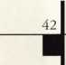

to [keynotes@anet-dfw.co](mailto:keynotes@anet-dfw.co)

Authors Wanted

Share your Knowledge and experience with others in the field by writing both technical and non-technical features for upcoming issues of Keynotes.

We will send you $$$$$$ for your contribution!*

For more information on Editorial Guidelines Payment Criteria contact Patanya Johnson Managing Editor at (214) 827-1701 Ext. 19

send an e-mail

Keynotes

3003 Live Oak Street Dallas, TX 75204 (214)827-1701 (214)827-1810 fax

* Amount is based on length of text and number of photos included.

Keynotes September 2000

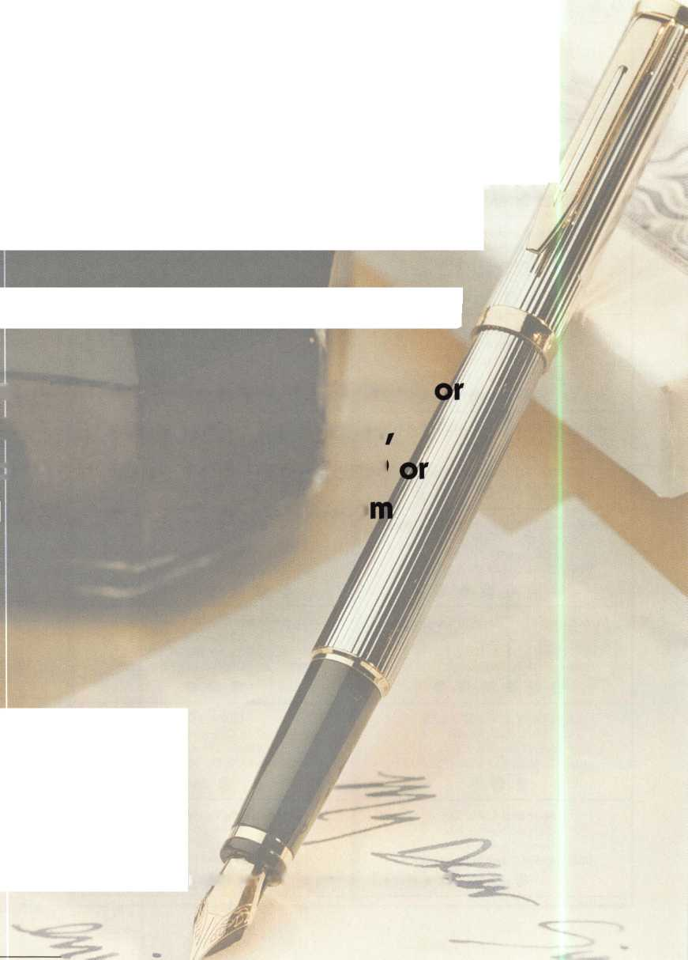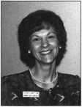

*Claire L. Cohen*, the second woman to become a CML, has been in locksmithing since 1977 and has been writing articles for Keynotes since 1987. She is also a contributing editor for Keynotes.

*Donald B. Dennis, CPL* has been dealing with the Locksmithing profession since 1972 with a four year apprenticeship in Albuquerque, New Mexico. He founded and has been the owner of Dennis Safe & Lock in Johnson City, Tennessee since 1977. He was the founder of the East Tennessee Locksmith Association in 1988 and is currently the Chairman of the Education Committee and editor of ETLA Newsletter.

*P*

*Sal Dulcamaro,* CML, has been in the  
locksmith business for over 25 years. He is  
the president of All Pro Security, Inc. in  
Michigan and has been an ALOA member  
~ for 18 years. A past president of the

Locksmith Security Association of Michigan. Sal currently  
serves as editor of the association newsletter. He was named  
Keynotes Author of the Year” for 1996 and 1997. He is  
also a contributing editor for Keynotes.

*Tim McMullen* oversees legislative affairs for ALOA. He is a graduate of the District of Columbia School of Law and has an extensive background in legislative work.

|  |  |
| --- | --- |
| Keynotes Advertisers Index | |
| Advertisers | Page |
| ALOA 2000 Thank You | 1 |
| ALOA 2001 | IBC |
| Hickok, Inc. | IFC |
| MasterLink Security Products | 12 |
| Marray Enterprises | 35 |
| SAFETECH 2001 | 14 |
| Safe Tech Reference Manual | 32 |
| Security Lock Company | 17 |
| Stam Insight | 13 |
| Turn 10 | 9 |
| UPP | 27 |
| W-Lok | BC |
| Yankee Security | 30 |



September 2000

Keynotes

A New Look for Keynotes!

Next month, Keynotes will have a new look! Please note that at this point it is merely a temporary change. We are experimenting with various designs in order to determine what would be the most effective in communicating with our members.

The most important thing to remember, is that this is YOUR magazine. Therefore, your feedback is vital. We tried a new format in February of this year, but did not receive much in the way of comments, either negative or positive. So, we ask you to look over next months issue and tell us what you think.

We welcome all comments and questions regarding the change. Write or email us and let us know what you think.

Send all inquiries to:

Keynotes

3003 Live Oak Street Dallas, TX 75204 (214) 827-1810 Fax [keynotes@anet-dfw.com](mailto:keynotes@anet-dfw.com)

begin with one.

to begin a new CclTGGT in locksmithing,

develop a new business strategy, or advance your skills in lock technology

there's only OPIG place you need to go.



ALOA 2001

C3

E

Ol

CM

VO

LO

CM

CM

m

uo

•

o

o

00

become one with your industry july 16-22

at baltimore convention center

K3

U

C

.o

4->

ro

E

£

C

O)

i_

o

E

baltimorG, maryland

o

• 100% Stainless Steel

UI-LOK

Stainless Steel  
Security Solutions

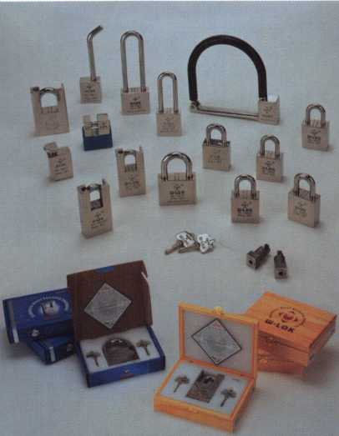

W-I0K Corporation 801 Productions Place Holland, Ml 40423

Toll Free: 0II.355.WL0K Fax: 010.355.4205

Well: [www.wlokcorp.com](http://www.wlokcorp.com)

Email: [office@wlokcorp.com](mailto:office@wlokcorp.com)

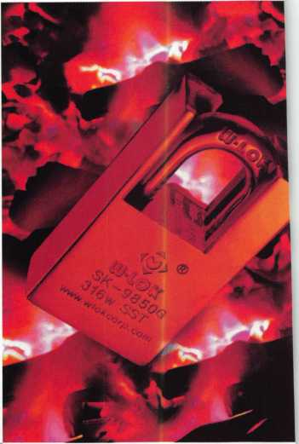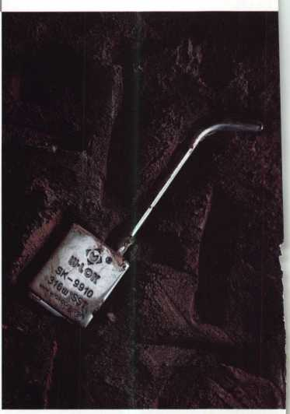

* Dealerships Available
* Representative Opportunities
* Custom Designs
* OEM Capabilities
* Internet Partnerships

